Schema-Guided Breadth-First Discovery of Hardware Resources in Heterogeneous Redfish Services
Master’s Thesis
[Author Name] — [University Name], [Faculty / Department of Computer Science]
Supervisor: [Supervisor Name]
[Month Year]
Contents

Abstract
The DMTF Redfish standard replaced the Intelligent Platform Management Interface (IPMI) with a RESTful, hypermedia-driven interface to the Baseboard Management Controller (BMC) of a server. In principle a client needs to know only one URI, the service root /redfish/v1; every other resource is reached by following links. In practice, monitoring tools are written against a fixed set of URI paths, and those paths differ between vendors, firmware generations and schema releases: power supplies live under Chassis/{id}/Power in one server and under Chassis/{id}/PowerSubsystem/PowerSupplies in the next; drives can hang below SimpleStorage, Storage or directly below the chassis. Hard-coded navigation therefore silently loses components whenever the monitored fleet changes.
This thesis treats the Redfish service as what the standard says it is, a graph of typed resources, and turns the question “which URI do I call for the power supplies?” into a graph search. The resource graph is restricted to its containment edges, which yields an almost-tree rooted at the service root, and the monitored components are described declaratively by their schema types (e.g. PowerSupply) rather than by their location. A breadth-first search (BFS) over this tree finds every instance of the requested types regardless of where a vendor placed them. To make the search affordable on slow BMCs, the thesis derives a type reachability graph from the published DMTF JSON Schema bundle and uses it to prune, before any request is sent, every subtree that cannot contain a requested type. The resulting algorithm, schema-pruned BFS (SP-BFS), is proven sound for schema-conformant services, falls back to conservative expansion for vendor extensions, handles legacy embedded arrays, and exposes level-synchronous parallelism.
The approach is evaluated on 26 recorded Redfish services from six sources (DMTF reference mockups, Dell iDRAC, HPE iLO, HPE Cray EX, Gigabyte and Intel) spanning Redfish protocol versions 1.0.2 to 1.20.0. Hard-coded navigation written for one schema generation recovers only 49 % (modern paths) or 78 % (legacy paths) of the 2,248 monitored components; even a hand-maintained union of both misses storage devices on three HPE servers. SP-BFS recovers 99.7 % of the components, exactly as many as an exhaustive tree traversal, while issuing 3.9$×$ fewer HTTP requests in total (5$×$ in geometric mean per server). Its request count is within a factor of 1.22 (geometric mean) of the hand-maintained union, without any vendor-specific code. With 16 concurrent requests the discovery of all servers fits into 333 request rounds instead of 3,461. The thesis concludes that schema-guided graph search is a practical way to make Redfish monitoring robust against vendor and version heterogeneity.
Keywords: Redfish, out-of-band management, Baseboard Management Controller, hardware monitoring, REST, hypermedia, breadth-first search, schema-guided traversal, interoperability.

List of Abbreviations
API | Application Programming Interface
BFS | Breadth-First Search
BMC | Baseboard Management Controller
CSDL | Common Schema Definition Language (OData)
DCIM | Data Center Infrastructure Management
DFS | Depth-First Search
DMTF | Distributed Management Task Force
DSP | DMTF Standard Publication
HATEOAS | Hypermedia as the Engine of Application State
HPC | High-Performance Computing
HTTP(S) | Hypertext Transfer Protocol (Secure)
iDRAC | integrated Dell Remote Access Controller
iLO | HPE Integrated Lights-Out
IPMI | Intelligent Platform Management Interface
JSON | JavaScript Object Notation
MIB | Management Information Base
OData | Open Data Protocol
OEM | Original Equipment Manufacturer
PSU | Power Supply Unit
REST | Representational State Transfer
SNMP | Simple Network Management Protocol
SP-BFS | Schema-Pruned Breadth-First Search (this thesis)
URI | Uniform Resource Identifier

1 Introduction

1.1 Motivation
Every modern server contains a small, independent computer, the Baseboard Management Controller (BMC), that watches the health of the machine even while the host operating system is down. It reads temperature and voltage sensors, drives the fans, records hardware faults and lets an operator power-cycle the machine remotely. For two decades the dominant interface to the BMC was the Intelligent Platform Management Interface (IPMI) [1], a binary protocol with a flat sensor model and a well-documented list of security weaknesses. In 2015 the Distributed Management Task Force (DMTF) published Redfish, a successor built from web technology: HTTPS, JSON and a REST-style resource model described by machine-readable schemas [2], [3]. Redfish is now supported by every major server vendor and by the open-source OpenBMC firmware, and it is the basis of monitoring pipelines in data centres and high-performance computing (HPC) sites [4], [5], [6].
The appeal of Redfish for a monitoring tool is obvious: instead of vendor specific command-line utilities or SNMP MIBs, a single HTTP client can ask any server for its processors, memory modules, drives, network adapters, power supplies and fans. The author experienced the other side of this promise while building a server hardware monitoring tool on top of Redfish. The standard fixes the types of resources and their properties, but it leaves the arrangement of the resources largely to the implementation, and the schema itself has evolved substantially:
- A Dell PowerEdge server with an iDRAC running Redfish 1.0.2 reports its power supplies as an array inside /redfish/v1/Chassis/System.Embedded.1/Power; the DMTF reference servers of the 2026 schema bundle additionally expose /redfish/v1/Chassis/1U/PowerSubsystem/PowerSupplies/{id}, because the Power resource was deprecated in favour of PowerSubsystem in Redfish release 2020.4.
- Physical drives appear below Systems/{id}/SimpleStorage (as embedded Devices), below Systems/{id}/Storage/{id}/Drives, or directly below Chassis/{id}/Drives, depending on vendor and generation.
- Resource identifiers are chosen by the implementation (1, System.Embedded.1, 437XR1138R2, Self, Node0), so even the same path template cannot be written down as a literal URI.
A tool written against one server therefore returns incomplete data on the next one, and it usually does so silently: a missing link is indistinguishable from a server that simply has no such component. Deciding “which REST API has to be called for storage, network, power or processors” turned out to be the hardest part of building the tool, and every newly supported server model required new special cases.
The solution that emerged in the tool, and which this thesis develops, formalises and evaluates, is to stop encoding where a resource lives and to describe only what it is. The Redfish service is converted into a tree of resources rooted at /redfish/v1, and the resources of interest are found by a breadth-first search (BFS) that matches the @odata.type of every visited node. The standard explicitly supports this view: Redfish is a hypermedia API in the sense of Fielding’s REST constraints [7], in which clients are expected to discover resources by following links rather than by constructing URIs.

1.2 Problem Statement
A naive graph search, however, is expensive. BMCs are embedded processors with limited CPU and memory; a single Redfish GET often takes tens to hundreds of milliseconds, and some implementations throttle concurrent sessions. The services studied in this thesis contain between 68 and 1,811 resources, most of which (log entries, JSON schema files, message registries, account and session objects) are irrelevant to hardware monitoring. Crawling the whole tree to find two power supplies is wasteful and slow. The problem addressed by this thesis is therefore:
How can a monitoring client locate all instances of a given class of hardware resource in an arbitrary, possibly non-uniform Redfish service, without vendor-specific navigation code and with a number of requests close to that of a hand-written, service-specific client?

1.3 Research Questions
RQ1
How heterogeneous are real Redfish services with respect to the placement of monitoring-relevant resources, and how much do hard-coded navigation paths miss?
RQ2
Does a type-based breadth-first search over the containment tree find the monitored components completely, independent of vendor and schema version?
RQ3
Can the published Redfish schema be used to prune the search so that its request cost approaches that of hand-written navigation, without losing completeness?
RQ4
What are the latency characteristics of the search (time to first result, parallelism across tree levels), and how does its one-time cost amortise over a monitoring session?

1.4 Contributions
- A formal model of a Redfish service as a typed, labelled resource graph whose containment edges form an almost-tree, together with declarative resource queries that name component classes by schema type, embedded-array location and content predicate (Chapter 4).
- Schema-pruned BFS (SP-BFS), a discovery algorithm that combines breadth-first traversal with a type reachability graph extracted automatically from the DMTF JSON Schema bundle. We prove that it is sound, i.e. loses no target that an exhaustive tree traversal finds, for any schema-conformant service, and we analyse its cost and its level-synchronous parallelism (Chapter 5).
- An implementation as the discovery layer of a monitoring tool, separating a one-time discovery phase from a cheap polling phase with event-driven rediscovery (Chapter 6).
- An empirical study on 26 recorded Redfish services from six vendor families and seven protocol versions, which quantifies placement heterogeneity and compares SP-BFS with hard-coded navigation and with exhaustive BFS/DFS (Chapter 7). All code, data and figures are reproducible from the accompanying repository.

1.5 Thesis Outline
Chapter 2 introduces out-of-band management, the Redfish data model and graph search. Chapter 3 reviews prior work on Redfish-based monitoring, hypermedia clients, web crawling and API evolution. Chapter 4 formalises the discovery problem and characterises the heterogeneity of real services. Chapter 5 presents SP-BFS and its analysis, Chapter 6 the implementation, and Chapter 7 the evaluation. Chapter 8 concludes and outlines future work.

2 Background
This chapter summarises the technical foundations the thesis builds on: out-of-band server management and its protocols (Section 2.1), the Redfish resource model and its versioning rules (Section 2.2), and breadth-first search (Section 2.3).

2.1 Out-of-Band Server Management
Out-of-band management refers to monitoring and controlling a computer through a path that does not depend on its host operating system. In servers this path is provided by the BMC, a service processor on the motherboard with its own network interface, firmware and power domain. The BMC is connected to the platform’s sensors (temperatures, voltages, fan tachometers), to the power sequencing logic and, increasingly, to management buses of add-in devices such as network adapters, storage controllers and GPUs. Vendor BMC products include Dell’s iDRAC, HPE’s iLO and Lenovo’s XClarity Controller; OpenBMC is a Linux Foundation project providing an open-source BMC firmware stack [8].
IPMI. The Intelligent Platform Management Interface, specified by Intel, HP, NEC and Dell in 1998 and last revised as version 2.0 in 2004 [1], defines a binary request/response protocol (with the RMCP+ transport over UDP) and a flat model of sensor data records. IPMI has three properties that motivated its replacement: its data model cannot describe modern component hierarchies (multi-node chassis, NVMe drives, GPUs); its commands are extended through vendor-specific OEM codes; and BMC firmware built around it has a history of serious security weaknesses that expose the whole server to attackers on the management network [9].
SNMP. Many data centres monitor hardware via the Simple Network Management Protocol [10], [11], where a vendor MIB exposes BMC or host-agent data as a tree of object identifiers. MIB trees are statically numbered and vendor specific; a monitoring tool needs one MIB per vendor. Interestingly, the SNMP GetNext walk is itself a tree traversal, an idea we revisit for Redfish.

2.2 The Redfish Standard
Redfish is developed by the DMTF Redfish Forum (formerly the Scalable Platforms Management Forum). Version 1.0 of the protocol specification DSP0266 was released in 2015 [12]; the protocol and its schemas have since been extended several times a year [2], [3], [13]. The Storage Networking Industry Association (SNIA) extends Redfish for storage systems under the name Swordfish [14].

2.2.1 Protocol
A Redfish service is an HTTPS server, usually running on the BMC. Its service root is always /redfish/v1; all other URIs are opaque to clients, which are expected to find them by following links. Resources are JSON documents [15] retrieved with GET; they are changed with PATCH, created in collections with POST, and actions (e.g. ComputerSystem.Reset) are invoked by POST on action targets. Authentication uses HTTP Basic authentication or session tokens (X-Auth-Token). Besides the network path, the Host Interface specification lets software on the host reach the same service in-band [16], and PLDM for Redfish Device Enablement lets add-in devices such as network and storage controllers contribute their own resources to the BMC’s tree [17]; the latter is one reason why the shape of the tree depends on the installed hardware. The DMTF’s Redfish User Guide describes typical client workflows on top of these mechanisms [18]. The protocol borrows its conventions from the OASIS Open Data Protocol (OData) version 4 [19], [20], [21]:
- @odata.id is the URI of a resource, and a JSON object of the form {"@odata.id": "/redfish/v1/Systems/1"} is a reference to another resource;
- @odata.type is the fully qualified, versioned type of a resource, e.g. #Processor.v1_7_0.Processor;
- a resource collection has a Members array of references and a Members@odata.count; long collections are paged with Members@odata.nextLink;
- query parameters such as $expand, $select and $filter are optional features that a service may advertise in its ProtocolFeaturesSupported object.
Listing 2.1 shows a processor resource from a DMTF reference mockup. Its link EnvironmentMetrics leads to a subordinate resource, whereas OriginOfCondition, nested in the status conditions, merely points to the sensor that raised a warning and lives elsewhere in the hierarchy.
Listing 2.1: Abridged Processor resource (DMTF mockup public-rackmount1, schema bundle 2026.2).
{
"@odata.id": "/redfish/v1/Systems/437XR1138R2/Processors/CPU1",
"@odata.type": "#Processor.v1_24_0.Processor",
"Id": "CPU1",
"Socket": "CPU 1",
"ProcessorType": "CPU",
"TotalCores": 8,
"Status": {
"State": "Enabled", "Health": "OK", "HealthRollup": "Warning",
"Conditions": [ {
"MessageId": "Sensor.1.0.ReadingAboveUpperCautionThreshold",
"OriginOfCondition": { "@odata.id": "/redfish/v1/Chassis/1U/Sensors/CPU1Temp" }
} ]
},
"EnvironmentMetrics": {
"@odata.id": "/redfish/v1/Systems/437XR1138R2/Processors/CPU1/EnvironmentMetrics"
}
}

2.2.2 Resource model
The schema defines roughly three hundred resource types. The top of the hierarchy is fixed by the service root, which links to collections such as Systems (logical computer systems), Chassis (physical enclosures and boards), Managers (BMCs), UpdateService, SessionService, AccountService, EventService, Registries and JsonSchemas. Hardware components are reached from systems and chassis:
- ComputerSystem $→$ Processors, Memory, Storage, SimpleStorage, EthernetInterfaces, NetworkInterfaces, …
- Chassis $→$ Power / PowerSubsystem, Thermal / ThermalSubsystem, Sensors, NetworkAdapters, Drives, PCIeDevices, …
The specification distinguishes two kinds of links. Properties of a resource that reference subordinate resources (Processors, Power, Members) define a containment hierarchy. References inside the Links object express other relations and “shall contain links to resources that are related to but are not contained by, or subordinate to, this resource” [22]. Two further groups of references do not denote containment either: Actions contain POST targets, and the object Oem holds vendor-defined extensions, whose content is outside the standard.

2.2.3 Schemas and versioning
Every resource type is published by the DMTF as CSDL (OData XML), JSON Schema [23] and OpenAPI [24] documents in the schema bundle DSP8010. A JSON Schema file exists for every released version of every type (e.g. Chassis.v1_9_0.json), plus an unversioned file listing all versions. Redfish follows strict compatibility rules: minor versions only add properties, and properties are never removed but may be deprecated. The deprecation that affects monitoring most is the power and thermal model introduced in release 2020.4: Chassis.Power and Chassis.Thermal, whose power supplies, fans and temperatures are embedded arrays, were deprecated in Chassis v1.15.0 in favour of PowerSubsystem and ThermalSubsystem, whose PowerSupply and Fan members are separate resources. Because deprecated properties remain valid, services in the field implement the old model, the new model or both.
Vendors extend the model in two ways: OEM properties inside Oem objects, with OEM schemas (e.g. HpeiLO), and placement choices that the standard leaves open, such as whether drives are linked from Storage, from Chassis, or both. The DMTF publishes mockups, static file-system snapshots of complete services, as reference material, together with tools to serve and record them [25], [26]. Interoperability profiles (DSP0272) allow a consumer to state which resources and properties it requires [27], and the Redfish Service Validator checks conformance of a live service against the schema [28].

2.3 Breadth-First Search
Given a directed graph $G=\left(V,E\right)$ and a source $r$, breadth-first search visits the vertices in non-decreasing order of their distance $d\left(v\right)$ from $r$. It keeps a first-in-first-out queue $Q$ and a set of discovered vertices; each dequeued vertex $u$ enqueues all undiscovered successors $w$ and records $u$ as their parent. The parent pointers form the BFS tree, a shortest-path tree of $G$ from $r$. BFS runs in $O\left(\left|V\right|+\left|E\right|\right)$ time [29]. It was introduced by Moore for finding shortest paths through a maze [30] and is the standard traversal order of web crawlers, where it tends to discover important pages early [31].
Two properties of BFS are central to this thesis. First, the frontier at distance $d$, the set $L_{d}=\{v:d\left(v\right)=d\}$, is complete before any vertex of $L_{d+1}$ is expanded. All requests of one level are therefore independent and can be issued concurrently (level-synchronous BFS). Second, BFS reaches each vertex along a shortest path, which for Redfish is the canonical, least deeply nested location of a resource. Depth-first search (DFS) uses a stack instead of a queue and has the same asymptotic cost, but it reaches deep vertices early and its frontier offers no natural unit of parallelism.

3 Related Work
This thesis sits at the intersection of four lines of work: out-of-band monitoring systems built on Redfish (Section 3.1), client libraries and tools that talk to Redfish services (Section 3.2), hypermedia-driven clients and web crawling (Section 3.3), and the evolution of web APIs and its effect on clients (Section 3.4).

3.1 Redfish-Based Monitoring
Standards and overviews. The DMTF’s white paper introduced Redfish as a “RESTful interface” for “scalable platform management” that replaces IPMI [12]; the Redfish and OData white paper explains the annotation conventions (@odata.id, @odata.type) on which our graph model rests [21]. Gonçalves et al. survey the standard for the communications community [32]. The specification itself anticipates the problem studied here. It states that “different hardware or device types result in different resource trees, even for identical systems from the same manufacturer,” that “references between resources may result in a graph instead of a tree,” that clients traversing the tree “should provide logic to avoid infinite loops,” and that clients “should not assume that they can reuse hyperlinks across different Redfish service instances” (DSP0266 §5.3 [2]). It further requires that “clients shall not make assumptions about the URIs for the members of a resource collection” (§7.2.2) and describes discovery “through referenced URIs” from the single service root as the intended access method (§5.4.4). The specification thus mandates discovery, but it does not say how a client should discover efficiently. This thesis addresses that gap.
HPC monitoring. The group of Chen, Sill, Hass and colleagues at Texas Tech University has published most of the academic work on Redfish monitoring. Hojati et al. benchmarked Redfish against IPMI for automated hardware management [33] and built the Redfish Green500 Benchmarker for automated power measurement [34]. MonSTer collects BMC and scheduler metrics for a 467-node cluster; it reads thermal data from the Dell-specific URI /redfish/v1/Chassis/System.Embedded.1/Thermal/, reports an average of 4.29 s per Redfish request and about 55 s for an asynchronous sweep of all nodes, and notes that the iDRAC “has limited resources and cannot handle a large number of requests” [4], [35]. Redfish-Nagios integrates Redfish into the Nagios monitoring system using a fixed table of URIs under Systems, Chassis and Managers [5]; its extended version reports node round-trip times between 4.13 and 5.82 s [36]. Dakić et al. combine the Redfish API of HPE iLO servers with the vSphere API for policy-based monitoring, addressing resources such as /redfish/v1/Systems/1 directly [6]. Outside Redfish, LDMS provides scalable in-band metric collection for HPC [37], and DiG adds a dedicated out-of-band board for high-resolution power monitoring, contrasting it with the roughly one-second resolution achievable over IPMI [38].
Two observations motivate this thesis. First, all of these systems address resources by hard-coded URI templates tuned to the vendor of their cluster. None of them evaluates what happens on a different vendor or firmware generation. Second, their latency measurements show that each request to a BMC is expensive, on the order of seconds under load. A discovery algorithm that crawls a service of 1,000 resources sequentially would take more than an hour at that rate, so request count is the right cost measure.
Security. BMCs are a sensitive attack surface. Bonkoski et al. analysed the IPMI implementation of a major BMC vendor and found vulnerabilities that expose the host [9]; PMFault shows that the BMC’s access to the power management bus can be used to fault or permanently damage server CPUs [39]; and Almeida et al. use Redfish as a case study for securing RESTful asset management APIs under IEC 62443-4-2 [40]. For our purposes these works imply that monitoring clients should run with read-only accounts and issue as few requests as possible, which again favours pruned discovery.

3.2 Redfish Client Libraries and Tools
The DMTF maintains a Python client library that handles sessions, paging and JSON parsing but leaves navigation to the caller [41]. Sushy, the Redfish library of OpenStack Ironic, wraps selected resources in Python classes with fixed attribute paths; its documentation warns that BMCs “are very flaky” and advises minimising requests [42]. The Prometheus redfish_exporter maps a fixed set of resources to metrics [43]. OpenBMC’s bmcweb is a server-side implementation [8], [44].
Closest to our approach are two DMTF tools that traverse a service. The Redfish Mockup Creator walks the complete resource graph and stores every resource as a file [26]; the resulting mockups can be replayed by the Mockup Server [25] and are the data source of our evaluation. The Redfish Service Validator crawls a service and checks every resource against its @odata.type schema, including JSON Pointer fragments of embedded objects [28], [45]. Both tools are exhaustive by design. This thesis instead targets selective traversal for a known set of component types, and it uses the schema not to validate what was fetched but to decide what need not be fetched at all.
The Redfish Interoperability Profiles (DSP0272) let a client publish which resources and properties it relies on and let a validator check a service against that profile [27]. Profiles detect whether a service provides what a client needs; they do not tell the client where to find it. Since protocol version 1.6.0 the schemas also carry URI patterns, and conforming services implement them (DSP0266 §5.4.5, §9.13.5 [2]). URI patterns narrow the search space but do not remove it. The 2026.2 bundle lists 21 permitted URI patterns for Processor, 10 for EthernetInterface, 8 for Drive, 7 for Memory and 6 for Sensor. Every pattern contains identifier variables that can only be bound by reading collections, and services older than 1.6.0, such as the Dell iDRAC mockups studied here, predate the patterns entirely. Section 7.7.1 discusses how URI patterns and SP-BFS complement each other.

3.3 Hypermedia Clients and Web Crawling
Fielding’s REST architectural style requires that clients drive application state through hypermedia links provided by the server (the HATEOAS constraint) [7]. URIs are to be discovered, not constructed; the generic URI syntax defines only how a path is written, not what its segments mean [46]. Most practical REST clients ignore this constraint and hard-code endpoint templates from documentation, which is exactly the failure mode we observe in Redfish tools. Redfish is one of the few widely deployed APIs whose specification insists on hypermedia discovery, which makes it a natural setting for a hypermedia-driven client.
Web crawlers solve a related problem at a larger scale. Najork and Wiener showed that breadth-first crawling discovers high-quality pages early [31]; Cho et al. studied how to order the crawl frontier so that important pages are fetched first [47], and how an incremental crawler should revisit pages as the web changes [48]. Our setting differs in three respects: the graph is small but each request is very expensive; the client knows exactly which node types it wants; and a machine-readable schema describes which types can occur below which. The schema allows exact pruning with a soundness guarantee rather than the heuristic frontier ordering of general crawlers. The discover-then-poll structure of our monitoring tool mirrors the incremental crawler’s separation of discovery and revisiting.

3.4 Web API Evolution
Empirical studies of web API evolution show that API changes regularly break clients. Li et al. classified the changes of five popular web APIs and their impact on client code [49]; Espinha et al. interviewed client developers and analysed client code, finding that even “loosely coupled” web APIs create strong coupling through hard-coded endpoints [50], [51]; Sohan et al. studied which changes providers make between API versions and how they document and communicate them [52]. Redfish is unusual in that its compatibility rules forbid removing properties, but deprecation plus optional features plus vendor freedom in placement still produce the silent breakage that these studies describe. The approach in this thesis can be read as a client-side strategy to decouple from such changes: the client depends only on type names, which are stable across versions, and on the published schema, which is versioned and machine readable.

3.5 Summary
Existing Redfish monitoring systems hard-code vendor-specific URIs and report per-request latencies of seconds. Existing Redfish tools either leave navigation to the user or traverse exhaustively. Web crawling offers traversal strategies but no schema-based pruning. To the best of our knowledge, no prior work (i) systematically measures placement heterogeneity across Redfish vendors and versions, or (ii) uses the Redfish schema to prune the discovery of monitored components with a completeness guarantee. These are the gaps the following chapters address.

4 Problem Analysis and Formal Model
This chapter turns the informal question “which URI has to be called to get the power supplies?” into a precise search problem. Section 4.1 models a Redfish service as a typed graph, Section 4.2 shows why its containment edges form an almost-tree, Section 4.3 defines resource queries, and Section 4.4 classifies the kinds of heterogeneity a discovery algorithm has to tolerate.

4.1 The Resource Graph
Definition 4.1 (Resource graph). A Redfish service is a labelled directed multigraph
$G=\left(V,E,r,τ,β\right), E⊆V×Π×P×V$ (4.1)
where $V$ is the set of resource URIs that answer a GET, $r=\text{/redfish/v1}$ is the service root, $τ:V→T∪\{⊥\}$ maps a resource to the short name of its @odata.type (e.g. PowerSupply) or to $⊥$ if the type is missing, and $β\left(v\right)$ is the JSON body of $v$. An edge $\left(u,p,π,w\right)∈E$ exists if the body $β\left(u\right)$ contains, at JSON Pointer [45] $π$ below the top-level property $p∈Π$, an object $\{\text{"@odata.id"}:w\}$ with $w≠u$.
Every edge is classified by the property names on its pointer $π$. We partition
$E=E_{c} \dot{∪} E_{x} \dot{∪} E_{o} \dot{∪} E_{a}$ (4.2)
into containment edges $E_{c}$; cross references $E_{x}$, where some key on $π$ is Links, RelatedItem, RedundancyGroup or OriginOfCondition; OEM edges $E_{o}$, where some key is Oem; and action/settings edges $E_{a}$, where some key is Actions or @Redfish.Settings. Edges in $E_{a}$ point to POST targets and pending-configuration copies and are never traversed.
Remark 4.1. URIs in Redfish are opaque: a client must not infer the type or the parent of a resource from its path. The model therefore uses URIs only as identifiers, and all structural information comes from the edges.

4.2 The Containment Tree
The Redfish specification describes resources as organised in a hierarchy below the service root, in which each subordinate resource is referenced by a navigation property of its parent. In graph terms, the subgraph $G_{c}=\left(V_{c},E_{c}\right)$ of vertices reachable from $r$ over containment edges is expected to be a rooted tree. Real services deviate from this ideal in three ways: the same drive is linked from both a Storage and a Chassis resource; a ResourceBlock of the composition service re-exposes processors and memory of a system; and a few vendor resources appear in more than one collection. We therefore call $G_{c}$ an almost-tree and measure how far it is from a tree by the share of vertices with more than one containment parent,
$μ\left(G\right)=\frac{|\{w∈V_{c}:\left|\{u:\left(u,⋅,⋅,w\right)∈E_{c}\}\right|>1\}|}{\left|V_{c}\right|}$ (4.3)
Across the 26 services of the evaluation, $μ=3.1 \%$ overall and at most $12.1 \%$ for a single service (Chapter 7). A BFS over $G_{c}$ turns the almost-tree into a proper tree $T$ by keeping, for every vertex, the edge through which it was first discovered; by the BFS property this is a shortest path from $r$. The depth $d\left(v\right)$ of a vertex is its distance from $r$ in $G_{c}$, and the levels of the tree are
$L_{k}=\{v∈V_{c}:d\left(v\right)=k\}, k=0,…,D$ (4.4)
where $D=\max_{v}d\left(v\right)$ is the height of the tree. All services studied have $6≤D≤8$ (see Figure 7.7).

4.3 Resource Queries
A monitoring tool is interested in a small number of hardware classes. Instead of a location, a class is described by what its instances are.
Definition 4.2 (Resource query). A resource query is a triple $Q=\left(P,M,φ\right)$ where $P⊆T$ is a set of resource types, $M⊆T×Π$ is a set of embedded locations (a parent type and one of its array properties), and $φ:T×JSON→\{0,1\}$ is a content predicate. The answer of $Q$ on $G$ is
$\begin{matrix}A_{Q}\left(G\right) = & \{ v∈V_{c}:τ\left(v\right)∈P∧φ\left(τ\left(v\right),β\left(v\right)\right) \} \\ ∪ & \{ ι\left(v,m,i\right):v∈V_{c}, \left(τ\left(v\right),m\right)∈M, 0≤i<\left|β\left(v\right)\left[m\right]\right| \},\end{matrix}$ (4.5)
where $ι\left(v,m,i\right)$ is the identity of the $i$-th element of array $m$ in $β\left(v\right)$: the element’s own @odata.id if it has one without a fragment, and the JSON-Pointer URI v#/m/i otherwise.
The embedded part $M$ is needed because older schemas describe components as array elements rather than resources: in Power v1 the power supplies are elements of PowerSupplies, in Thermal v1 the fans and temperature readings are elements of Fans and Temperatures, and in SimpleStorage the drives are elements of Devices. The identity function $ι$ matters for services such as early iDRAC firmware, which give each embedded element a dereferenceable URI that is also reachable as a separate resource of type PowerSupply; without $ι$ the same power supply would be counted twice.
Definition 4.3 (Anchor types). The anchor types of $Q$ are the types whose bodies must be fetched to evaluate $Q$:
$Anc\left(Q\right)=P∪\{t:\left(t,m\right)∈M\}$ (4.6)
Table 4.1 lists the six queries used by the monitoring tool and in the evaluation. They are the only service-independent knowledge the tool requires.
Table 4.1: Resource queries of the monitoring tool. $φ$ is true unless stated.
Query | Types $P$ | Embedded locations $M$ | Predicate $φ$
Processor | Processor | – | ProcessorType is not Core or Thread
Memory | Memory | – | –
Storage | Drive | (SimpleStorage, Devices) | –
Network | EthernetInterface, NetworkAdapter | – | –
Power | PowerSupply | (Power, PowerSupplies) | –
Thermal | Fan, Sensor | (Thermal, Fans), (Thermal, Temperatures) | for Sensor: ReadingType is Temperature
Scope. The tool monitors the host, not the BMC itself. Resources below Managers (the BMC’s own Ethernet interfaces, logs and accounts) are excluded by a set $X=\{\text{ManagerCollection},\text{Manager}\}$ of excluded types whose subtrees are not entered.
Discovery problem. Given query $Q$ and access to $G$ only through GET requests starting at $r$, compute $A_{Q}\left(G\right)$ while minimising the number of requests
$C=\left|\{v∈V:v\text{ is fetched}\}\right|$ (4.7)
Because $G$ is unknown in advance, every algorithm has to fetch at least the resources that contain the answer and one path of ancestors to each of them. An exhaustive traversal of $G_{c}$ fetches all of $V_{c}$, which is complete but expensive. A hard-coded client fetches a fixed set of paths, which is cheap but complete only for services laid out as expected.

4.4 Heterogeneity of Redfish Services
The discovery problem is only interesting because services differ. From the schema history and the services in Chapter 7 we distinguish five kinds of heterogeneity. Figure 4.1 illustrates three of them with concrete paths from three recorded services.
H1
Identifier heterogeneity. Member identifiers are chosen freely (1, System.Embedded.1, 437XR1138R2, Self, Node0, QSBP74100021). Literal URIs never transfer between vendors.
H2
Model generation. The same component is described by different types in different schema generations, e.g. an embedded element of Power.PowerSupplies versus a PowerSupply resource below PowerSubsystem; a SimpleStorage device versus a Drive. Services may implement both generations at once.
H3
Placement. The standard permits several parents for the same type. Drives are linked from Storage, from Chassis or from a composition ResourceBlock; network adapters are found below Chassis, Ethernet interfaces below ComputerSystem.
H4
Optional features. $expand, $select and $filter are optional, so a client cannot rely on server-side query evaluation to find resources.
H5
Vendor extensions and defects. OEM subtrees, resources without @odata.type, and links placed outside the standard’s navigation properties.
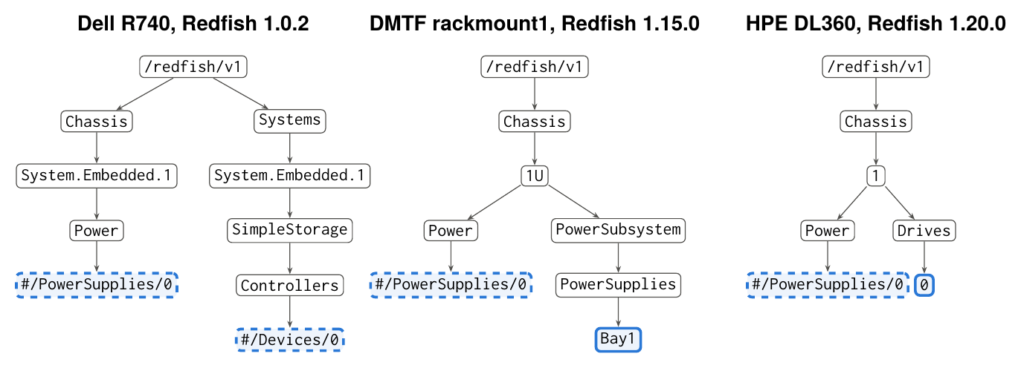
Figure 4.1: Placement of power supplies and drives in three recorded services (paths abridged; only relevant branches shown). Solid blue boxes are target resources, dashed boxes are embedded array elements. The same query must match all of them.
H1 and H4 exclude the naive solutions (literal URIs, server-side filters). H2 and H3 are what defeats hard-coded navigation, and they are the focus of this thesis. H5 is the reason why a discovery algorithm must degrade gracefully when the schema cannot tell it what a link means.

5 Schema-Guided Breadth-First Discovery
This chapter presents the discovery method. Section 5.1 gives an overview, Section 5.2 constructs the type reachability graph from the Redfish schema, Section 5.3 states the schema-pruned BFS algorithm, and Sections 5.4, 5.5 and 5.6 analyse its correctness, cost and parallelism. Section 5.7 embeds the algorithm into a monitoring loop.

5.1 Overview
The starting point is the plain idea behind the author’s monitoring tool: convert the service into a tree by following links from /redfish/v1, and find the requested resources by BFS, testing the @odata.type of every node. We call this Tree-BFS. It needs no vendor knowledge, and by construction it finds every target reachable over containment edges. Its weakness is cost: it fetches the entire containment tree, including thousands of log entries, schema files and registry entries that can never contain a power supply.
The key observation is that the client does not have to fetch a resource to know that nothing interesting can lie below it. The Redfish schema states, for every resource type and every navigation property, which types the property can point to. The client can therefore decide from the parent’s type and the property name alone whether a link can lead to a target. The resulting algorithm, schema-pruned BFS (SP-BFS), has two phases:
- Offline: build a type graph $H$ from the DMTF JSON Schema bundle and precompute reachability (Algorithm 1). This is done once per schema bundle and is independent of any service.
- Online: run BFS from the service root, evaluating the queries on each fetched body and enqueuing only those links whose possible target types can reach an anchor type of some query (Algorithm 2).
Figure 5.1 illustrates the effect on the upper levels of a service: all service-level branches except Systems, Chassis and CompositionService are pruned at the service root, and below a system or chassis only the branches that can lead to a monitored type survive.
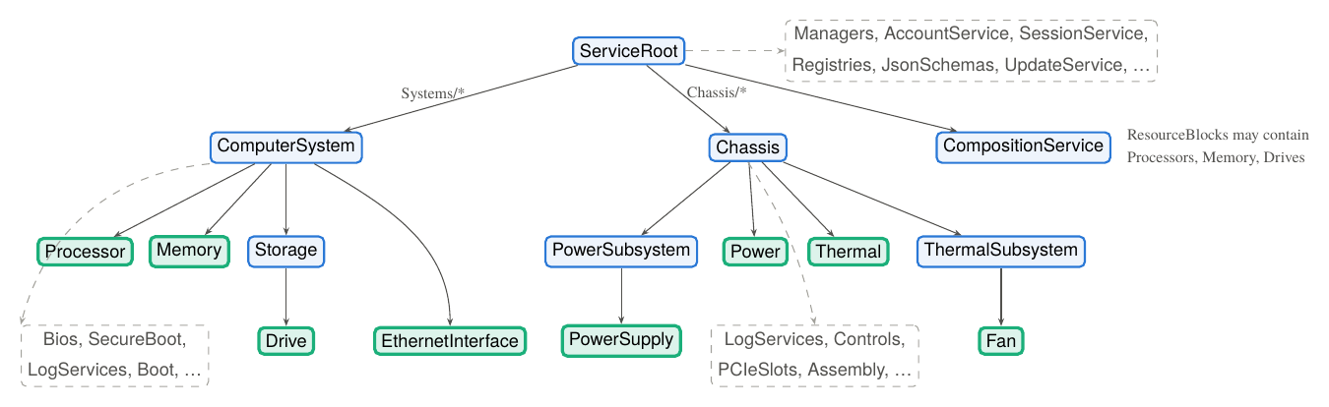
Figure 5.1: Schema pruning on the upper levels of a service for the six queries of Table 4.1 (intermediate collection resources omitted). Blue nodes are expanded, green nodes hold anchor types, and dashed grey branches are pruned before any request is sent because no anchor type is reachable from them in the type graph $H$.

5.2 The Type Reachability Graph
Definition 5.1 (Type graph). Let $T$ be the set of resource types defined in the schema bundle and $Π$ the set of property names. The type graph is
$H=\left(T,F\right), F⊆T×Π×T$ (5.1)
with $\left(t,p,t′\right)∈F$ if and only if some published version of type $t$ declares a top-level property $p$, other than Links, Actions and Oem, whose JSON Schema subtree contains a reference $ref to the definition of resource type $t′$. We write $H\left(t,p\right)=\{t′:\left(t,p,t′\right)∈F\}$ for the possible targets of property $p$ of type $t$, and $Decl\left(t\right)$ for the set of top-level properties declared by any version of $t$.
Taking the union over all versions makes $H$ valid for every schema version a service may implement, from a Redfish 1.0 service that only knows Chassis.Power to a 2026 service that also knows Chassis.PowerSubsystem. Collections are ordinary types: the edge $\left(\text{PowerSupplyCollection},\text{Members},\text{PowerSupply}\right)∈F$ is obtained from the Members array of the collection schema.
For a set $X⊆T$ of excluded types, the reachability of a type is the reflexive-transitive closure of $H$ avoiding $X$:
$R_{X}\left(t\right)=\{t\}∪\{ t′∈T\backslash X:∃ t=t_{0},t_{1},…,t_{k}=t′\text{ with }t_{i+1}∈H\left(t_{i},p_{i}\right), t_{1},…,t_{k}∉X \}$ (5.2)
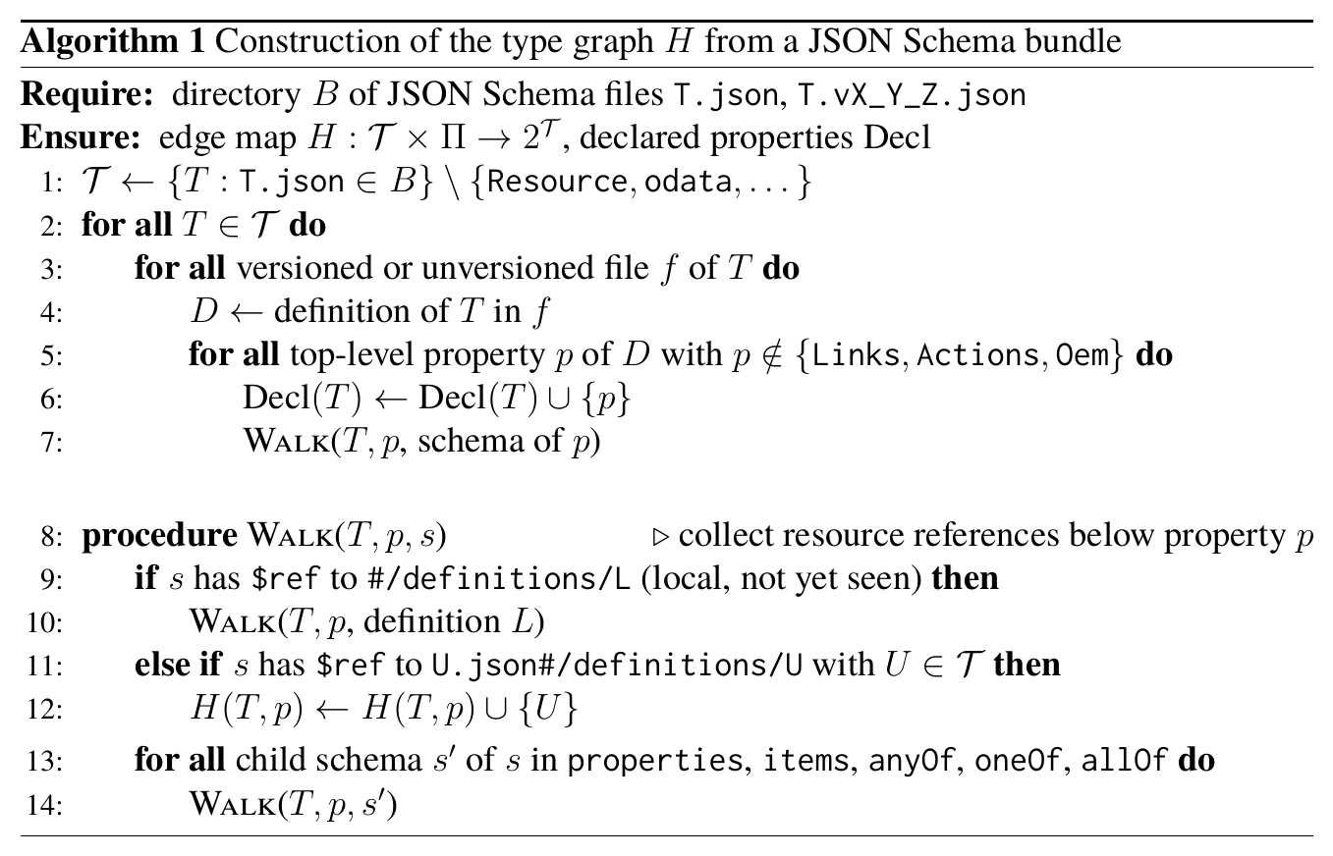
Applied to the DMTF schema bundle 2026.2 (6,826 versioned JSON Schema files), Algorithm 1 yields $\left|T\right|=278$ resource types and $\left|F\right|=499$ labelled edges in about one second. Reachability sets are computed lazily by BFS on $H$ and memoised, so each $R_{X}\left(t\right)$ costs $O\left(\left|T\right|+\left|F\right|\right)$ once.
Expansion rule. During discovery, a reference found in the body of a node $u$ of type $t=τ\left(u\right)$ under top-level property $p$ is expanded (its target is enqueued for fetching) according to the following rule, where $A=⋃_{j}Anc\left(Q_{j}\right)$ is the union of the anchor types of all active queries:
$expand\left(t,p\right)=\left\{\begin{matrix}\text{true} & \text{if }t=⊥\text{ or }p∉Decl\left(t\right)\text{ (unknown)}, \\ ∃ t′∈H\left(t,p\right)\backslash X: R_{X}\left(t′\right)∩A≠∅ & \text{otherwise.}\end{matrix}\right.$ (5.3)
Three consequences of Eq. (5.3) are worth noting. (i) If $p$ is declared but is not a navigation property ($H\left(t,p\right)=∅$), references inside it, such as Status/Conditions/*/OriginOfCondition, are cross references and are never followed. (ii) Vendor-specific properties that are not in the schema, and resources without @odata.type, are expanded, so the rule degrades to plain Tree-BFS rather than losing data. (iii) Oem, Links and Actions subtrees are skipped entirely, as in Tree-BFS.

5.3 The SP-BFS Algorithm
Algorithm 2 gives the complete discovery procedure. It evaluates any number of queries in a single traversal, which is how the monitoring tool uses it; a single-query call is the special case $m=1$.
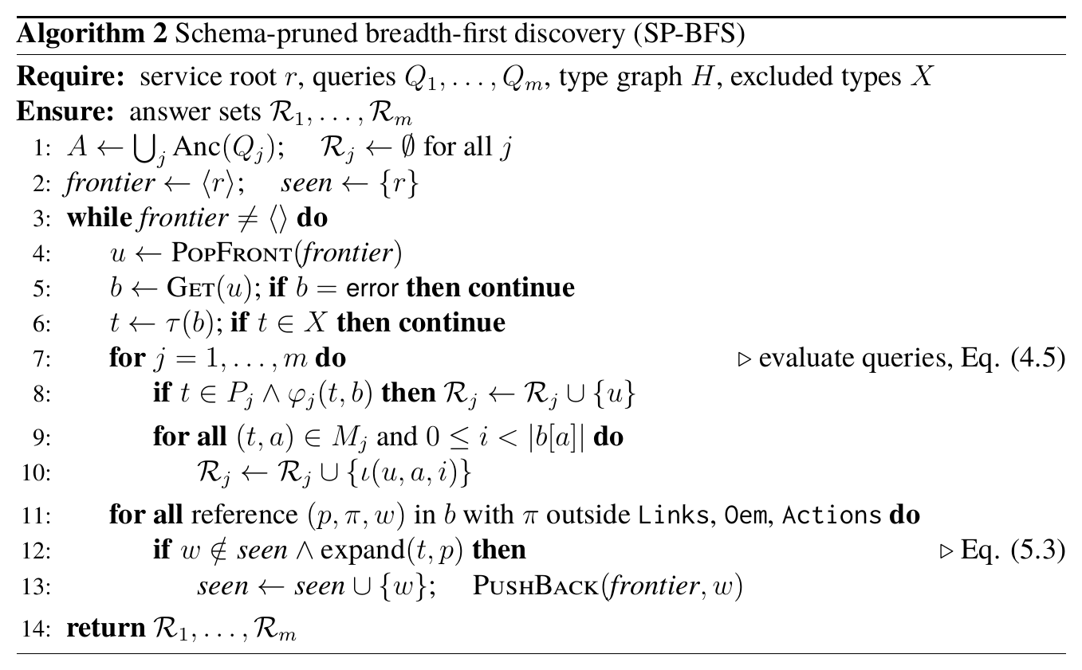
Details. References are extracted by a recursive walk over the body that records, for each object with an @odata.id other than the resource’s own, the top-level property and the JSON Pointer of the object. References whose target differs from $u$ only by a fragment point into $u$ itself and are handled by the embedded part of the query. Members@odata.nextLink pages are treated as members of the same collection. The seen set makes the algorithm terminate on graphs with cycles, as DSP0266 requires of traversing clients. A reference rejected by Eq. (5.3) is not added to seen, so the same resource can still be discovered through another, admissible parent.

5.4 Soundness and Necessity
Pruning is only acceptable if it never loses a target that the exhaustive traversal would find. We make precise which services this can be guaranteed for.
Definition 5.2 (Schema conformance). A service $G$ is schema-conformant with respect to $H$ if every vertex $v∈V_{c}$ has a type $τ\left(v\right)∈T$, and every containment edge $\left(u,p,π,w\right)∈E_{c}$ satisfies $p∈Decl\left(τ\left(u\right)\right)$ and $τ\left(w\right)∈H\left(τ\left(u\right),p\right)$.
Conformance is exactly what the Redfish Service Validator checks for each link: the target of a navigation property has the type declared by the schema.
Theorem 5.1 (Soundness). Let $G$ be schema-conformant and let $V_{c}^{X}$ be the set of vertices reachable from $r$ in $G_{c}$ by paths whose inner vertices have types outside $X$. Then for every query $Q_{j}$, SP-BFS returns
$$R_{j} = A_{Q_{j}}\left(G\right)∩(V_{c}^{X}∪\{ι\left(v,a,i\right):v∈V_{c}^{X}\}),$$
i.e. exactly the answers that Tree-BFS with the same exclusions returns.
Proof. ($⊆$) Every element added to $R_{j}$ satisfies the membership condition of Eq. (4.5) for the body in which it was found, and every fetched vertex is reached over containment edges from $r$ without expanding an excluded vertex.
($⊇$) Let $v∈V_{c}^{X}$ be a vertex whose body contributes an answer to $Q_{j}$, i.e. $τ\left(v\right)∈Anc\left(Q_{j}\right)⊆A$. Choose a containment path $r=v_{0}\overset{p_{0}}{→}v_{1}\overset{p_{1}}{→}⋯\overset{p_{k−1}}{→}v_{k}=v$ with $τ\left(v_{i}\right)∉X$ for $0<i<k$. By conformance, $τ\left(v_{i+1}\right)∈H\left(τ\left(v_{i}\right),p_{i}\right)$ for every $i$, so the type sequence $τ\left(v_{i+1}\right),…,τ\left(v_{k}\right)$ is a path in $H$ that avoids $X$, and therefore $τ\left(v\right)∈R_{X}\left(τ\left(v_{i+1}\right)\right)$. Hence $R_{X}\left(τ\left(v_{i+1}\right)\right)∩A∋τ\left(v\right)$ and $expand\left(τ\left(v_{i}\right),p_{i}\right)$ is true for every edge of the path. Consequently every edge of the path lies in the subgraph $G′⊆G_{c}$ of edges that Eq. (5.3) admits. SP-BFS is a breadth-first search of $G′$ (rejected edges do not mark their target as seen), so it fetches every vertex reachable from $r$ in $G′$, in particular $v$, and evaluates $Q_{j}$ on $β\left(v\right)$. ∎
Corollary 5.2. On schema-conformant services, SP-BFS and Tree-BFS have identical recall and precision for every query, and $C_{\text{SP-BFS}}≤C_{\text{Tree-BFS}}$.
For non-conformant services the expansion rule is conservative wherever the schema is silent (unknown types or properties). A target can then be lost only if a service links it through a declared property whose schema says it cannot lead there, i.e. through a genuine schema violation. Chapter 7 shows that this did not occur on any of the 26 services studied.
Soundness says that SP-BFS fetches no less than necessary. The converse question is whether it fetches more than necessary. Clearly it may: below a Processor it still visits SubProcessors, because in principle a processor can contain processors, even when the predicate excludes cores and threads. The following proposition shows that such requests cannot be avoided by any sound algorithm that has the same information.
Proposition 5.3 (Necessity). Let $B$ be any discovery algorithm that knows the schema $H$ but, like SP-BFS, learns about the service only by fetching resources, and that is sound on all schema-conformant services. Suppose $B$ has fetched $u$ and $β\left(u\right)$ contains a containment reference $\left(p,π,w\right)$ with $expand\left(τ\left(u\right),p\right)$ true, and $w$ is referenced by no other resource. Then $B$ must fetch $w$.
Proof sketch. Since $expand\left(τ\left(u\right),p\right)$ holds, there is a type path $t′=t_{1}→t_{2}→…→t_{k}∈A$ in $H$ with $t_{1}∈H\left(τ\left(u\right),p\right)$. Consider two services: $G$, and $\tilde{G}$ obtained from $G$ by giving $w$ the type $t_{1}$ and appending below $w$ a fresh chain of resources of types $t_{2},…,t_{k}$. Both services are schema-conformant, and they differ only at $w$ and below it. If $B$ does not fetch $w$, it observes identical responses on $G$ and $\tilde{G}$ and returns the same answer on both. But $\tilde{G}$ contains an answer of type $t_{k}$ that $G$ does not contain, so $B$ is unsound on one of them. ∎
In this sense SP-BFS is instance-optimal among schema-only algorithms: every request it issues could have been the one leading to a target. The remaining gap to a hand-written client comes from knowledge that is not in the schema, e.g. that a vendor never puts drives under a composition resource block. A hand-written client exploits such knowledge, and it is also what breaks when that knowledge becomes wrong.

5.5 Cost
Let $V′⊆V_{c}$ be the vertices reachable from $r$ in the admissible subgraph $G′$. The request cost of SP-BFS is exactly
$C_{\text{SP-BFS}}=\left|V′\right| ≤ \left|V_{c}\right|=C_{\text{Tree-BFS}}$ (5.4)
and its computation time is $O\left(\left|V′\right|+\left|E′\right|\right)$ for the traversal plus the one-off closure computations. With per-request latency $ℓ$ and sequential requests, the discovery time is $C⋅ℓ$. We report the pruning ratio
$ρ=\frac{C_{\text{SP-BFS}}}{C_{\text{Tree-BFS}}}, 0<ρ≤1$ (5.5)
and aggregate it over services by the geometric mean, which is the appropriate mean for ratios.
A lower bound for any discovery algorithm is the size of the union of the shortest paths from $r$ to the answer-bearing vertices, because each vertex on such a path must be fetched to learn the next link. For the query “all power supplies” on a modern service this is typically $\{r,\text{Chassis},\text{Chassis/1},\text{PowerSubsystem},\text{PowerSupplies}\}$ plus one request per supply, i.e. $4+n_{PSU}$ requests.

5.6 Level-Synchronous Parallelism
BFS processes the tree level by level. All vertices of level $L_{k}$ are known before any vertex of $L_{k+1}$ is fetched, so the requests of one level are independent and can be issued concurrently. Let $n_{k}=\left|L_{k}∩V′\right|$ and let the client keep at most $c$ requests in flight (BMCs typically limit the number of sessions and degrade under load, so $c$ is small). With the level barrier, the number of request rounds is
$R\left(c\right)=\sum_{k=0}^{D}{\left\lceil \frac{n_{k}}{c}\right\rceil }, max\left(K,\frac{C}{c}\right) ≤ R\left(c\right) ≤ K+\frac{C}{c}$ (5.6)
where C=k​nk and $K$ is the number of non-empty levels. The expected wall-clock time is approximately $R\left(c\right) \overset{‾}{ℓ}\left(c\right)$, where $\overset{‾}{ℓ}\left(c\right)$ is the mean latency at concurrency $c$. For $c→∞$ the time is bounded below by the height of the tree, which for Redfish is small ($D≤8$ in all services studied). DFS has the same total cost but no level structure, so its natural parallelisation requires speculative expansion of several branches.
BFS has one latency drawback that the evaluation makes visible: plain Tree-BFS must sweep the broad upper levels (schemas, registries, logs) before it reaches depth 4–6 where hardware components live, so its first answer arrives late. Pruning removes exactly those broad, irrelevant levels.

5.7 Discovery within a Monitoring Loop
Hardware inventory changes rarely, while sensor readings change continuously. The monitoring tool therefore separates discovery from polling (Algorithm 3). Discovery produces a poll set: the distinct URIs of the answer-bearing resources (the resource itself for resource answers, the parent for embedded answers such as Power#/PowerSupplies/0). Each polling cycle fetches only the poll set. Over $N$ cycles the mean cost per cycle is
$\overset{‾}{C}\left(N\right)=\frac{C_{disc}}{N}+C_{poll}\overset{N→∞}{→}C_{poll}$ (5.7)
so any discovery algorithm is amortised after a few cycles. What still matters is (i) the completeness of the poll set, which is fixed at discovery time, and (ii) the cost of rediscovery, which is needed when the inventory changes.
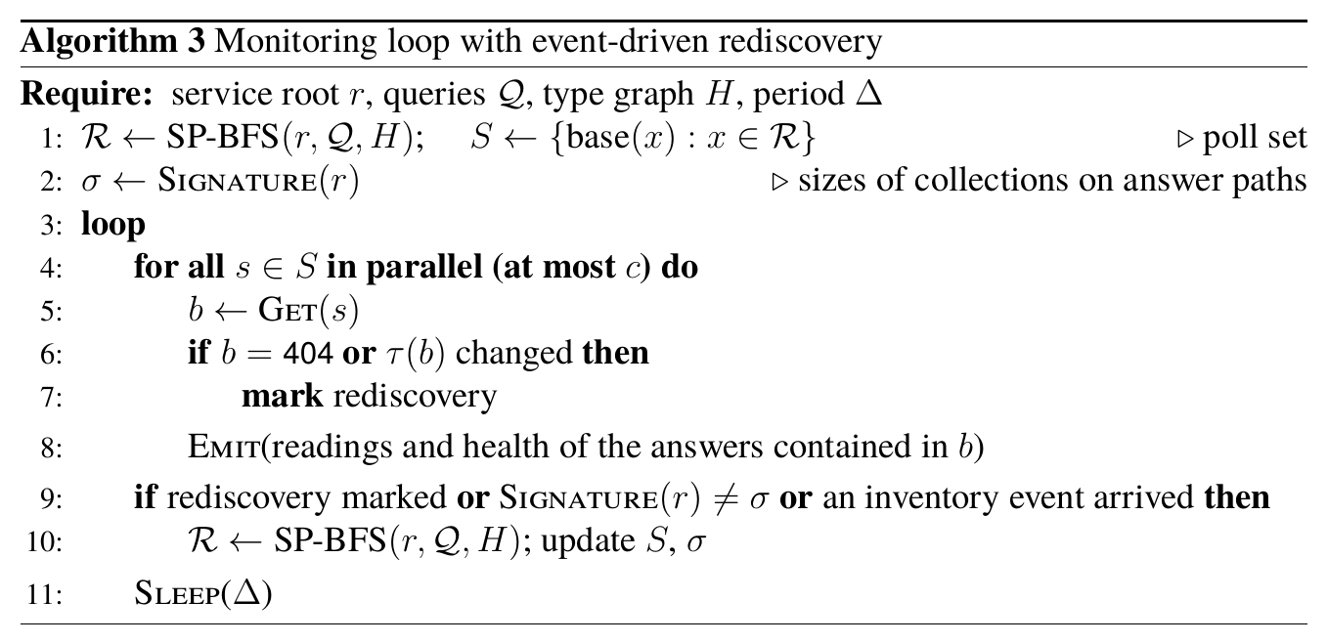
The signature is a cheap fingerprint of the inventory: the Members@odata.count of the collections on the paths to the answers, which are among the resources already fetched and can be re-read periodically at a fraction of the discovery cost. Redfish event subscriptions (ResourceAdded, ResourceRemoved) can trigger rediscovery immediately on services that support them.

6 Implementation
This chapter describes how SP-BFS is realised as the discovery layer of the Redfish hardware monitoring tool, and how the same code is exercised against recorded services for the evaluation.

6.1 Architecture
Figure 6.1 shows the components of the monitoring tool. The collector owns all communication with BMCs: it authenticates, limits the number of concurrent requests per BMC, applies timeouts and retries, and counts requests. The discovery component runs SP-BFS with the queries of Table 4.1 and the type graph built from the schema bundle; its only output is an inventory, i.e. the answer sets and the derived poll set, per server. The poller periodically fetches the poll set, normalises the readings (health state, temperature in °C, fan speed, power in W) into a vendor-neutral record keyed by the answer identity $ι$, and hands them to storage, dashboards and alerting. Nothing outside the discovery component knows a Redfish URI.
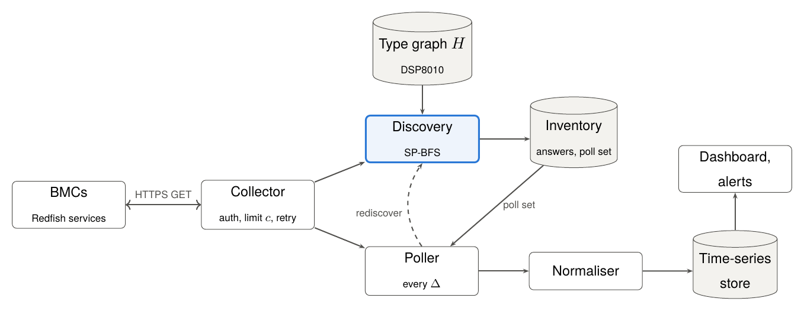
Figure 6.1: Architecture of the monitoring tool. Only the discovery component (blue) interprets the Redfish resource graph.

6.2 The rfbfs Package
The discovery layer is implemented in Python 3 without third-party dependencies, in six modules totalling about 670 lines:
service.py
The transport interface: a single method get(uri) that returns the JSON body or None and counts requests. The evaluation uses MockupService, which serves a DMTF mockup directory.
https.py
HttpsService, the transport for live BMCs with the same interface: session login with fallback to HTTP Basic authentication, optional acceptance of self-signed certificates, timeouts, and retries with exponential back-off for 5xx and 429 responses.
model.py
Reference extraction (Definition 4.1): a recursive walk that yields every @odata.id reference with its top-level property, JSON Pointer and edge class (containment, cross reference, OEM, action/settings), and the short type name $τ$ derived from @odata.type. The type name is the last dot-separated segment of the qualified name, which works for all historic spellings, e.g. #ComputerSystem.v1_1_0.ComputerSystem and #ProcessorCollection.ProcessorCollection.
schema.py
Algorithm 1 and the memoised reachability closure $R_{X}$ (Eq. (5.2)).
queries.py
The declarative queries of Table 4.1 as immutable data: type sets, embedded locations and predicates.
discover.py
One traversal routine that implements, via parameters, the ground-truth crawl, Tree-BFS, Tree-DFS and SP-BFS (Algorithm 2); a level-synchronous variant crawl_levels that fetches each tree level with a bounded thread pool; and the static navigation baselines used in Chapter 7.
Listing 6.1 shows how the monitoring tool invokes the discovery. Adding a new component class (e.g. GPUs or PCIe devices) means adding one query; no navigation code has to be written.
Listing 6.1: Using the discovery layer.
from rfbfs.schema import TypeGraph
from rfbfs.queries import QUERIES
from rfbfs.discover import crawl_levels
from rfbfs.https import HttpsService
H = TypeGraph.from_schema_dir("DSP8010_2026.2/json-schema") # once per bundle
svc = HttpsService("https://bmc-17.example", "monitor", secret,
verify_tls=False) # same get() interface
inv = crawl_levels(svc, list(QUERIES.values()), schema=H, workers=4) # SP-BFS
poll_set = {x.split("#")[0] for ids in inv.targets.values() for x in ids}

6.3 Engineering Aspects
Sessions and authentication. The collector creates one Redfish session per BMC (POST to the Sessions collection of the SessionService) and sends the returned X-Auth-Token with every request, falling back to HTTP Basic authentication where sessions are not available. The monitoring account needs only the read-only ReadOnly role.
Concurrency. Level-synchronous BFS (Section 5.6) is implemented by fetching the current frontier with a bounded worker pool before building the next one. The fetched level is then processed in document order, so the result, including the request count, is identical to the sequential traversal; we verified this on all 26 services of the evaluation. The bound $c$ is configurable per vendor because BMCs differ in how many parallel requests they tolerate.
Robustness. A failed request (timeout, 5xx, invalid JSON) is retried with exponential back-off and, if it still fails, recorded in the result’s list of failed URIs, so that the inventory is marked as incomplete instead of silently missing a branch. The mockups contain such defects too, e.g. URIs whose percent-encoding differs from the stored path and directories whose letter case differs from the advertised URI; the mockup transport tolerates both, as a careful HTTP client would.
Identity and deduplication. Answers are keyed by the identity function $ι$ of Definition 4.2, so the same power supply reported both as an embedded element and as a resource (early iDRAC firmware) is stored once. A remaining source of duplicates is services that implement both the legacy and the new power/thermal model. Their embedded and resource representations have different identities and are currently reported separately; merging them by their Location and serial-number properties is left as future work (Section 8.3).
Schema updates. The type graph is built from whatever schema bundle is configured. Because it is the union over all versions and schemas only ever add properties, a newer bundle can only add edges, so upgrading the bundle never makes pruning less sound.

6.4 Evaluation Harness
The evaluation (Chapter 7) runs every strategy against every mockup through the same MockupService, so that request counts are directly comparable. The script run_experiments.py writes per-mockup, per-category, per-query and per-level results as CSV/JSON files, and make_figures.py computes all aggregate numbers and figures reported in this thesis from those files. Appendix B lists the exact data sources and commands.

7 Evaluation
This chapter answers the research questions of Chapter 1 on 26 recorded Redfish services. Section 7.1 describes data, baselines and metrics; Sections 7.2, 7.3, 7.4 and 7.5 address RQ1–RQ4; Section 7.6 reports on the shape of the resource trees; and Section 7.7 discusses the results and threats to validity.

7.1 Experimental Setup

7.1.1 Services
Live access to many server models of different vendors and generations is rarely available to a single project. We therefore evaluate on mockups: complete recordings of Redfish services created with the DMTF Mockup Creator or equivalent tools, in which every resource is stored as the JSON document the BMC returned [26]. A mockup reproduces the resource graph exactly, so request counts and discovery results are identical to those against the live service. What a mockup cannot reproduce is latency, which we therefore model separately (Section 7.5).
We collected all public server mockups we could find, from four sources:
- the DMTF reference mockups of the Redfish-Publications repository at release 2026.2 (public-rackmount1, -tower, -bladed, -localstorage, -smartnic, -liquid-cooled-server);
- five Dell PowerEdge servers with iDRAC 7/8/9 firmware (R720, R740, T630, C6320, FC630) from Dell’s open-source Sailfish project;
- seven HPE ProLiant servers with iLO 5, iLO 6 and iLO 7 firmware from HPE’s iLO Redfish emulator;
- eight servers from the HPE Cray System Management Redfish emulator: three further HPE ProLiant/Apollo servers, three HPE Cray EX liquid-cooled compute blades, and one Gigabyte and one Intel server.
Mockups that do not describe a server (PDUs, cooling units, switches, fabric managers) were not included. The mockup of a stock OpenBMC build was excluded because its system and chassis collections are empty. The resulting 26 services span Redfish protocol versions 1.0.2 to 1.20.0 and contain between 68 and 1,811 resources, 16,869 in total. Table 7.1 lists them together with the main results.

7.1.2 Ground truth
For each service, the ground truth is obtained by a full graph crawl that follows all references, including Links and Oem subtrees, and evaluates the six queries of Table 4.1 on every resource. Answers inside the BMC’s own subtree (below a Manager) and pending-configuration copies referenced by @Redfish.Settings are removed, because they do not describe host hardware. The ground truth contains 2,248 monitored components: 82 processors, 456 memory modules, 108 drives, 134 network interfaces and adapters, 70 power supplies, and 1,398 fans and temperature sensors. Building it took 18,205 requests.

7.1.3 Strategies
Static-legacy
Hand-written navigation for the pre-2020 model: Systems/*/Processors/*, Systems/*/Memory/*, Systems/*/SimpleStorage/*#Devices, Systems/*/EthernetInterfaces/*, Chassis/*/Power#PowerSupplies and Chassis/*/Thermal#Fans,Temperatures. Collections are enumerated (*), so identifiers are not hard-coded. This is how the tools discussed in Section 3.1 work.
Static-modern
The same for the current model: Storage/*/Drives, Chassis/*/NetworkAdapters/*, PowerSubsystem/PowerSupplies/*, ThermalSubsystem/Fans/* and Chassis/*/Sensors/*.
Static-union
Both recipe sets, sharing a response cache, i.e. the best a maintainer who knows both schema generations can do with fixed paths. The recipes are listed in Appendix A.
Tree-DFS / Tree-BFS
Exhaustive traversal of the containment tree (excluding Links, Oem, Actions and the manager subtree) in depth-first or breadth-first order, evaluating the queries on every node. Tree-BFS is the original approach of the author’s tool.
SP-BFS
Algorithm 2 with the type graph of schema bundle 2026.2.

7.1.4 Metrics
For service $s$ and strategy $S$ with answer set $R_{S}\left(s\right)$ and ground truth $G\left(s\right)$ (both unions over the six queries) we report
${recall}_{S}\left(s\right)=\frac{\left|R_{S}\left(s\right)∩G\left(s\right)\right|}{\left|G\left(s\right)\right|}, {precision}_{S}\left(s\right)=\frac{\left|R_{S}\left(s\right)∩G\left(s\right)\right|}{\left|R_{S}\left(s\right)\right|}$ (7.1)
the micro-averaged recall over all services s​RSs∩Gs / s​Gs, the number of HTTP GET requests $C_{S}\left(s\right)$, the pruning ratio $ρ$ of Eq. (5.5), the request rounds $R\left(c\right)$ of Eq. (5.6), and the number of requests until the first answer of a single-category query. All strategies have precision 1 on all services, because every strategy evaluates the same query predicates on the bodies it fetches, so precision is not discussed further.
Table 7.1: The 26 services with protocol version, number of resources $\left|V\right|$, tree height $D$ and number of monitored components $\left|G\right|$; recall of the static strategies and SP-BFS; and GET requests for a complete discovery. Tree-BFS has the same recall as SP-BFS on every service. (R = recall, GET = HTTP GET requests; tree = Tree-BFS, SP = SP-BFS.)
Service | Redfish | $\left|V\right|$ | $D$ | $\left|G\right|$ | R legacy | R modern | R union | R SP | GET tree | GET union | GET SP
DMTF rackmount1 | 1.15.0 | 255 | 7 | 28 | 0.75 | 0.64 | 1.00 | 1.00 | 229 | 75 | 91
DMTF tower | 1.15.0 | 544 | 7 | 60 | 0.58 | 0.88 | 1.00 | 1.00 | 529 | 126 | 426
DMTF bladed | 1.15.0 | 82 | 6 | 27 | 1.00 | 0.15 | 1.00 | 1.00 | 50 | 34 | 34
DMTF localstorage | 1.15.0 | 68 | 6 | 18 | 0.78 | 0.67 | 1.00 | 1.00 | 55 | 24 | 25
DMTF smartnic | 1.15.0 | 144 | 8 | 24 | 0.54 | 0.75 | 0.92 | 0.92 | 131 | 80 | 98
DMTF liquid-cooled | 1.15.0 | 235 | 7 | 20 | 0.75 | 0.80 | 1.00 | 1.00 | 209 | 71 | 87
Dell R720 | 1.0.2 | 331 | 6 | 23 | 1.00 | 0.48 | 1.00 | 1.00 | 241 | 22 | 22
Dell R740 | 1.0.2 | 365 | 6 | 16 | 1.00 | 0.31 | 1.00 | 1.00 | 281 | 17 | 17
Dell T630 | 1.0.2 | 313 | 6 | 27 | 1.00 | 0.15 | 1.00 | 1.00 | 242 | 19 | 19
Dell C6320 | 1.0.2 | 251 | 6 | 12 | 1.00 | 0.33 | 1.00 | 1.00 | 216 | 15 | 15
Dell FC630 | 1.0.2 | 283 | 6 | 41 | 1.00 | 0.24 | 1.00 | 1.00 | 253 | 26 | 26
HPE DL325 G10+ | 1.6.0 | 877 | 6 | 70 | 0.94 | 0.36 | 1.00 | 1.00 | 647 | 39 | 60
HPE DL340e | 1.20.0 | 1222 | 7 | 76 | 0.84 | 0.43 | 1.00 | 1.00 | 958 | 78 | 88
HPE DL360 | 1.20.0 | 1361 | 8 | 106 | 0.92 | 0.41 | 0.94 | 1.00 | 1076 | 57 | 78
HPE DL360 G12 | 1.20.0 | 942 | 8 | 91 | 0.88 | 0.52 | 1.00 | 1.00 | 700 | 99 | 128
HPE DL365 G10+ | 1.20.0 | 1811 | 8 | 100 | 0.90 | 0.40 | 0.94 | 1.00 | 1410 | 54 | 91
HPE DL380a | 1.20.0 | 1487 | 8 | 112 | 0.83 | 0.44 | 1.00 | 1.00 | 1222 | 123 | 156
HPE DL380a G12 | 1.20.0 | 1714 | 7 | 181 | 0.83 | 0.37 | 0.96 | 0.98 | 1257 | 174 | 220
HPE DL325 (CSM) | 1.6.0 | 852 | 6 | 66 | 1.00 | 0.32 | 1.00 | 1.00 | 618 | 33 | 35
HPE XL675d A100 | 1.6.0 | 454 | 8 | 128 | 0.98 | 0.33 | 1.00 | 1.00 | 428 | 56 | 63
HPE XL675d A40 | 1.6.0 | 895 | 6 | 147 | 0.99 | 0.27 | 1.00 | 1.00 | 677 | 52 | 91
Cray EX235a | 1.2.0 | 389 | 6 | 116 | 0.52 | 0.67 | 1.00 | 1.00 | 354 | 225 | 239
Cray EX425 | 1.2.0 | 483 | 6 | 136 | 0.62 | 0.67 | 1.00 | 1.00 | 455 | 339 | 347
Cray EX4252 | 1.2.0 | 1182 | 6 | 534 | 0.58 | 0.64 | 1.00 | 1.00 | 1096 | 931 | 939
Gigabyte | 1.7.0 | 231 | 6 | 45 | 0.98 | 0.49 | 1.00 | 1.00 | 182 | 40 | 56
Intel | 1.1.0 | 98 | 6 | 44 | 1.00 | 0.18 | 1.00 | 1.00 | 78 | 27 | 27
Total / micro-average |  |  |  | 2248 | 0.78 | 0.49 | 0.99 | 1.00 | 13594 | 2836 | 3478

7.2 RQ1: Heterogeneity and Hard-Coded Navigation
Figure 7.1 shows, for every service, the property paths through which Tree-BFS first reached the storage, power, thermal and network components (collection members generalised to {id}, embedded array elements to #). Processors and memory are found under two templates each, power under two, network under three, thermal under four and storage under five. Storage is the most diverse: drives are embedded Devices of SimpleStorage on all Dell and most DMTF services, members of Chassis/{id}/Drives on six of the seven HPE iLO services, members of Storage/{id}/Drives on the DMTF tower, the HPE DL380a Gen12 and the HPE XL675d A100, and first reached through CompositionService/ResourceBlocks on the Gigabyte server. The deprecation of Power and Thermal splits the services into groups: the Dell, Intel, Gigabyte and most HPE services use only the legacy embedded arrays for power supplies; the DMTF reference services, four HPE iLO 6/7 services and the Cray blades additionally or exclusively expose PowerSubsystem, ThermalSubsystem or Sensors.
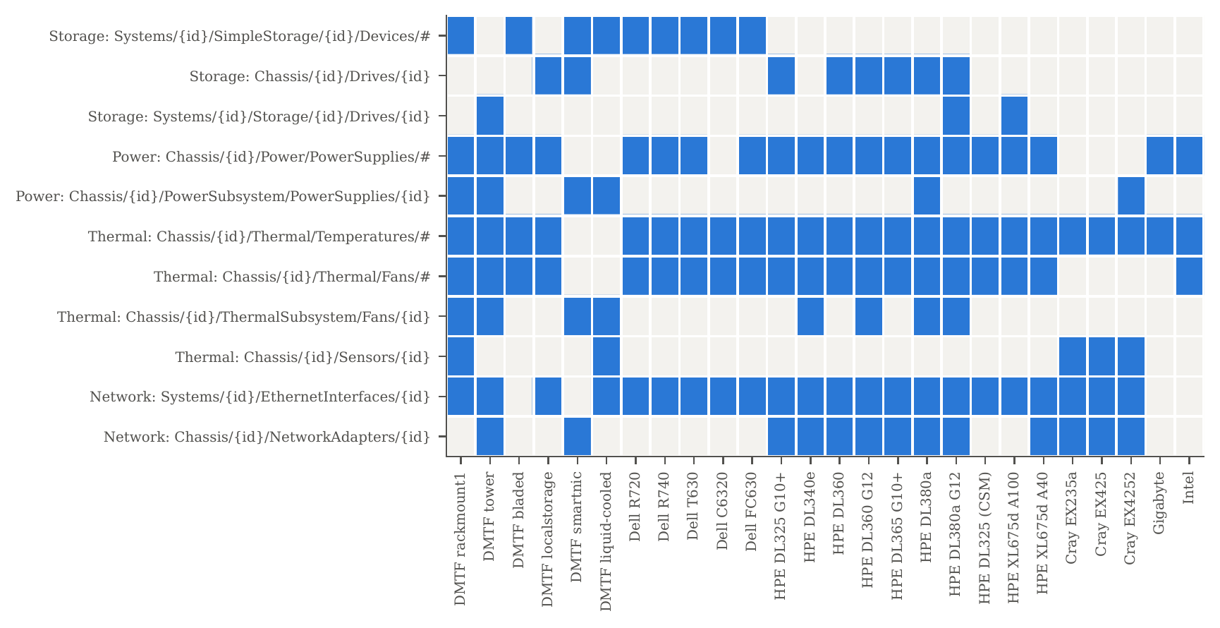
Figure 7.1: Where monitored components live. Rows are property-path templates (occurring in at least two services), columns are services; a filled cell means the service exposes components of that category under that template.
The consequences for hard-coded navigation are shown in Figures 7.2 and 7.3 and Table 7.2. Static-legacy reaches a micro-averaged recall of 0.785 and is complete on only 8 of 26 services, all of them Dell, DMTF-bladed, older HPE or Intel. Static-modern, which is what a developer would write from the current schema documentation, reaches only 0.490 and is complete on none of the services: its power recall is 0.23 and its thermal recall 0.26, because most services in the field still use the embedded legacy arrays. The union of both recipe sets reaches 0.990 and is complete on 22 services. It still misses 6 of 8 drives on the HPE DL360 and DL365 and 8 of 14 on the DL380a Gen12, because these drives are linked only from Chassis/{id}/Drives, a location that neither recipe set visits, so its storage recall is 0.815. These are exactly the failures that the author’s tool experienced in practice. Each of them was silent, and each would have required another vendor-specific path to fix.
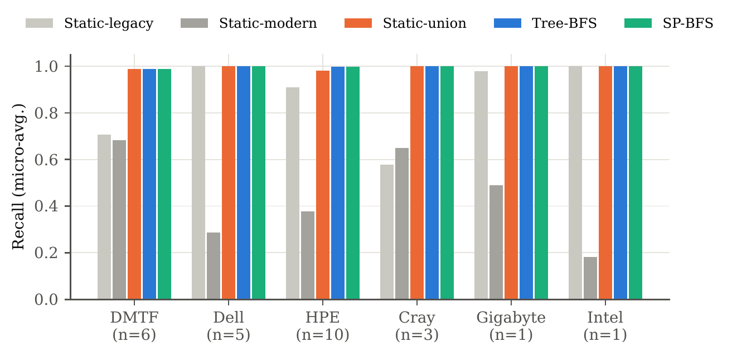
Figure 7.2: Micro-averaged recall per vendor family ($n$ = number of services).
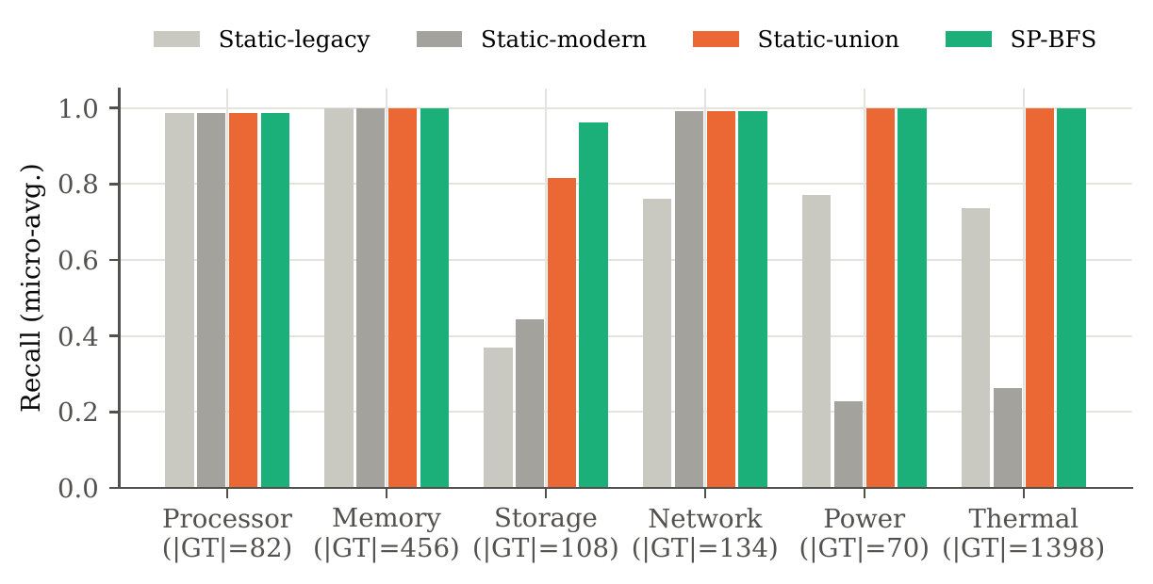
Figure 7.3: Micro-averaged recall per component category.
Table 7.2: Micro-averaged recall per category and overall.
Strategy | Processor | Memory | Storage | Network | Power | Thermal | All
Static-legacy | 0.988 | 1.000 | 0.370 | 0.761 | 0.771 | 0.737 | 0.785
Static-modern | 0.988 | 1.000 | 0.444 | 0.993 | 0.229 | 0.263 | 0.490
Static-union | 0.988 | 1.000 | 0.815 | 0.993 | 1.000 | 1.000 | 0.990
Tree-BFS | 0.988 | 1.000 | 0.963 | 0.993 | 1.000 | 1.000 | 0.997
SP-BFS | 0.988 | 1.000 | 0.963 | 0.993 | 1.000 | 1.000 | 0.997
Answer to RQ1. Real services differ substantially in where they place monitored components, mainly along the two axes H2 (schema generation) and H3 (placement). Hard-coded navigation for a single schema generation loses between 21 % and 51 % of the components; even a union of both generations loses components on three of the ten HPE ProLiant and Apollo servers.

7.3 RQ2: Completeness of Type-Based Tree Search
Tree-BFS and SP-BFS find 2,242 of the 2,248 ground-truth components (recall 0.997) and are complete on 24 of 26 services, independent of vendor and protocol version (Table 7.1). The six components they miss are reachable only through non-containment references:
- On the DMTF smartnic mockup, a network adapter of a SmartNIC card chassis and its FPGA processor are linked only from the Links of a system’s network device function. The card’s chassis is not a member of the chassis collection.
- On the HPE DL380a Gen12, four drives are linked only from an HPE OEM resource directory (Oem/Hpe/Instances), not from any standard navigation property.
Both are arguably defects of the respective service, since DSP0266 expects every resource to be reachable through the resource tree. They illustrate the price of restricting the search to containment edges. Following Links as well would recover them, but it would turn the almost-tree into a dense graph (every processor links back to its chassis, every drive to its volumes and controllers) and multiply the request count.
Answer to RQ2. Yes. Matching @odata.type over the containment tree finds 99.7 % of the components on all vendors and versions without a single line of vendor-specific navigation. The remainder is attributable to resources that the services do not place in the containment tree.

7.4 RQ3: Cost of Schema-Pruned Search
Figures 7.4 and 7.5a compare the request counts. Exhaustive Tree-BFS needs 13,594 requests for the 26 services (523 per service on average), because it fetches every log entry, schema file, registry and account. SP-BFS needs 3,478 (134 per service), a reduction by a factor of 3.9 overall. The per-service pruning ratio $ρ$ has a geometric mean of 0.20, i.e. a five-fold reduction. It ranges from $ρ=0.057$ (HPE DL325 CSM, 35 instead of 618 requests) and $ρ=0.060$ (Dell R740, 17 instead of 281) to $ρ=0.86$ on the Cray EX4252. The EX4252 is a blade enclosure whose resources are mostly the monitored temperature sensors themselves, so there is little irrelevant content to prune. Recall is unaffected on every service (Theorem 5.1): all 26 services behaved as schema-conformant in the sense that no target was reached only through a pruned edge.
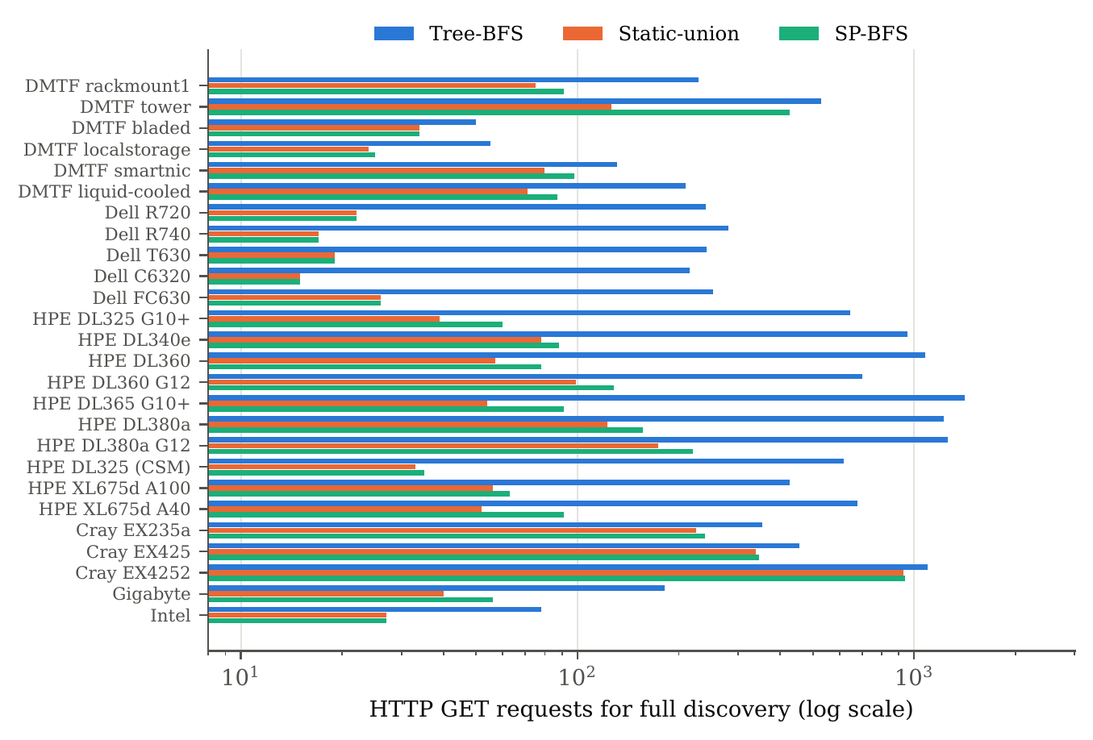
Figure 7.4: GET requests needed to discover all six categories on each service (log scale).
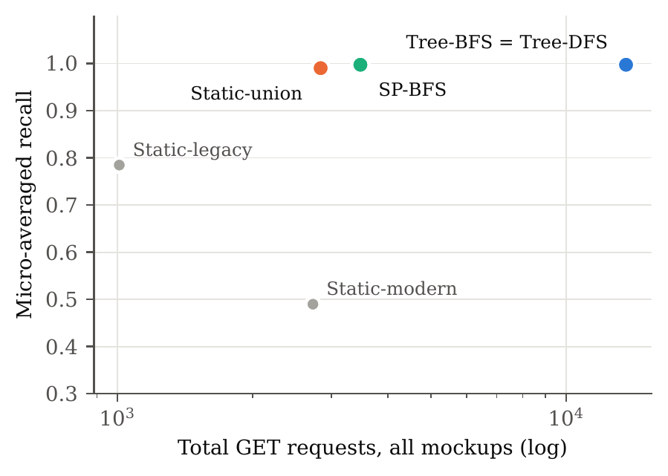
Figure 7.5a: Total requests versus recall.
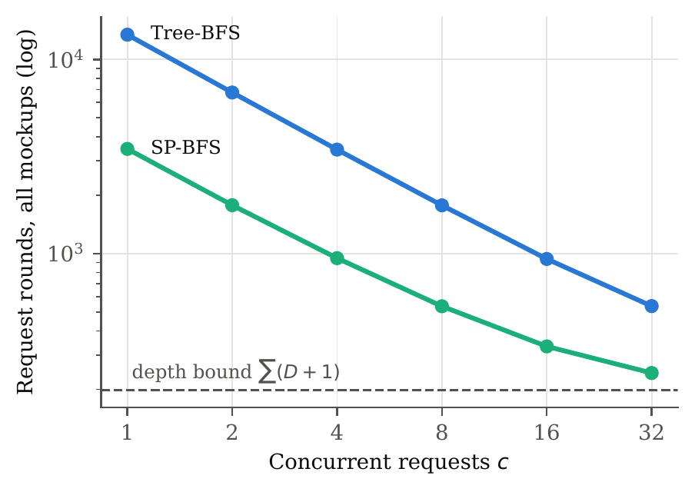
Figure 7.5b: Request rounds versus concurrency.
Figure 7.5: Cost trade-off (a) and level-synchronous parallelism (b), summed over all 26 services.
Table 7.3 lists the properties at which pruning happened most often. At the service root, Managers, SessionService, AccountService, EventService, Tasks, Registries, UpdateService, JsonSchemas and CertificateService are cut on almost every service. Below systems, the BIOS, boot, secure-boot and log services are cut; below chassis, PCIe devices and slots, assemblies and controls. The most frequent cuts, however, are references out of the legacy embedded arrays (Power.Voltages, Thermal.Fans, Power.PowerSupplies). Several vendors attach dereferenceable sensor URIs to each embedded element; the schema declares these arrays as embedded objects, not navigation properties, so their contents are already known and the links need not be followed.
Table 7.3: Most frequently pruned (type, property) pairs, summed over all services.
Type.property | Cuts | Type.property | Cuts
Power.Voltages | 123 | ServiceRoot.Registries | 23
Thermal.Fans | 42 | ServiceRoot.UpdateService | 19
Fan.Assembly | 36 | ServiceRoot.JsonSchemas | 19
ComputerSystem.Bios | 27 | ComputerSystem.LogServices | 18
ServiceRoot.Managers | 26 | ComputerSystem.Boot | 18
ServiceRoot.SessionService | 26 | ServiceRoot.CertificateService | 16
ServiceRoot.AccountService | 26 | ComputerSystem.SecureBoot | 16
ServiceRoot.EventService | 25 | Thermal.Temperatures | 16
ServiceRoot.Tasks | 24 | Power.PowerSupplies | 15
Compared with the hand-maintained Static-union, SP-BFS issues 23 % more requests in total (3,478 versus 2,836; geometric mean of the per-service ratio 1.22). On 7 services it issues exactly as many requests. The largest overheads are on the DMTF tower (3.4$×$), where SP-BFS descends into the 256 SubProcessors (cores and threads) of its eight CPUs because a processor can contain processors, and on three HPE servers (1.5–1.75$×$), where it descends into the network device functions and ports of the network adapters, because the schema allows EthernetInterface resources below a NetworkDeviceFunction. By Proposition 5.3, no algorithm that relies only on the schema can avoid these requests. Static-union avoids them only because its author knows, for this particular set of services, where drives do not occur. The same knowledge makes it miss the drives of the three HPE servers above.
Single-category queries. When only one category is requested, pruning is much stronger, because fewer anchor types keep fewer branches alive. Summed over all services that have the category, SP-BFS needs 162 requests to find all power supplies (7 per service, against 12,569 for Tree-BFS), 255 for all drives and 616 for all processors.
Computation. Building the type graph from the 2026.2 bundle takes about 1 s and is done once. The client-side processing of SP-BFS (reference extraction, query evaluation and pruning decisions, with the mockup file reads) takes 12 ms per service on average and at most 72 ms. This is negligible compared with a single BMC request.
Answer to RQ3. Yes. Schema pruning removes on average 80 % of the requests of exhaustive tree search (per-service geometric mean) without losing any component, and brings the cost to within about a quarter of a hand-written client that knows both schema generations. Unlike that client, it needs no vendor-specific code and is more complete.

7.5 RQ4: Latency, Parallelism and Amortisation
Time to first answer. Figure 7.6 compares, for each of the 138 (service, category) pairs with a non-empty ground truth, the number of requests a single-category traversal needs before it finds its first answer. Contrary to the intuition that BFS finds things early, exhaustive Tree-BFS is slower than Tree-DFS in 78 % of the cases (median 234 versus 48 requests): the shallow levels of a Redfish tree are wide and filled with irrelevant resources, and BFS must sweep all of them before it reaches the components at depth 4–6. SP-BFS removes these levels and finds the first answer after a median of 9 requests (5 for power and thermal, 13 for memory and network).
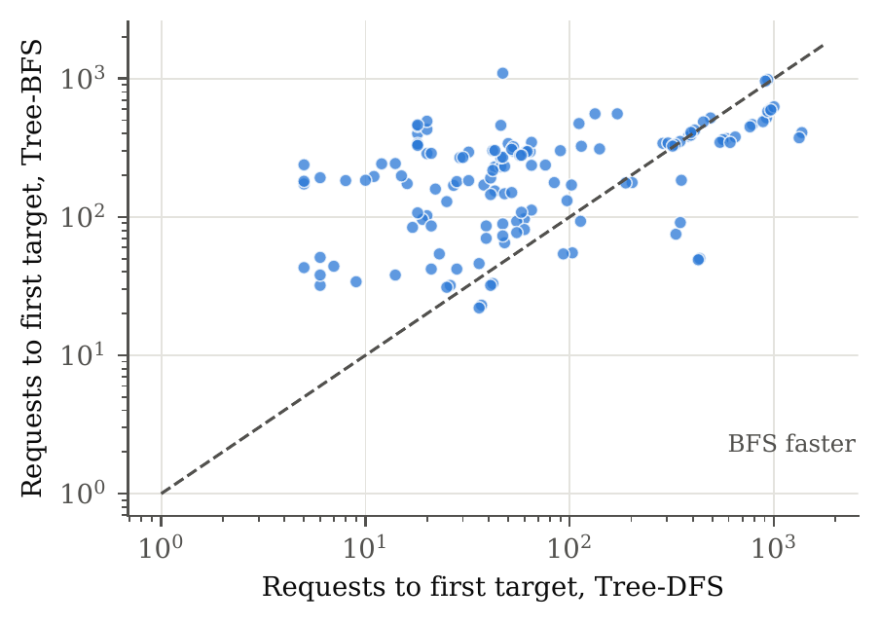
Figure 7.6: Requests until the first answer of a single-category query, Tree-BFS versus Tree-DFS (one point per service and category; points above the diagonal favour DFS).
Parallelism. Figure 7.5b shows the request rounds $R\left(c\right)$ of Eq. (5.6), summed over all services. Because the containment trees have only 6–8 levels, the level barrier costs little: SP-BFS needs 3,461 rounds at $c=1$, 948 at $c=4$, 536 at $c=8$ and 333 at $c=16$ (12.8 rounds per service on average), approaching the lower bound of 199 rounds given by the number of tree levels.
Latency model. Mockups carry no timing information, so we translate rounds into time with the per-request latency reported for iDRAC8 in production by MonSTer, $\overset{‾}{ℓ}=4.29s$ [4]. This is a pessimistic value measured under concurrent load. Under this model, an average service is discovered by Tree-BFS in $523×4.29 s≈37$ minutes sequentially, by SP-BFS in about 9.6 minutes, and by SP-BFS with $c=8$ in $20.6×4.29 s≈88$ seconds, provided the BMC sustains eight concurrent requests without slowing down. Real BMCs slow down under concurrency, so the parallel figure is a lower bound, but the ordering of the strategies does not depend on $\overset{‾}{ℓ}$.
Amortisation. After discovery, each polling cycle fetches the poll set: on average 47.8 resources per service for SP-BFS and Tree-BFS, and 47.2 for the less complete Static-union. By Eq. (5.7), the discovery cost of 134 requests is spread over the polling cycles: after ten cycles it adds only 13 requests per cycle, and with event-driven rediscovery (Algorithm 3) it recurs only when the inventory changes. Re-running an exhaustive Tree-BFS in every cycle, as a naive implementation of the original tool would, costs eleven times the polling set per cycle.
Answer to RQ4. Unpruned BFS has poor time-to-first-answer on Redfish because the upper tree levels are wide and irrelevant; pruning fixes this (median 9 requests). The shallow trees make level-synchronous parallelism effective, and the discovery cost is amortised after a few polling cycles when discovery and polling are separated.

7.6 Shape of Redfish Resource Trees
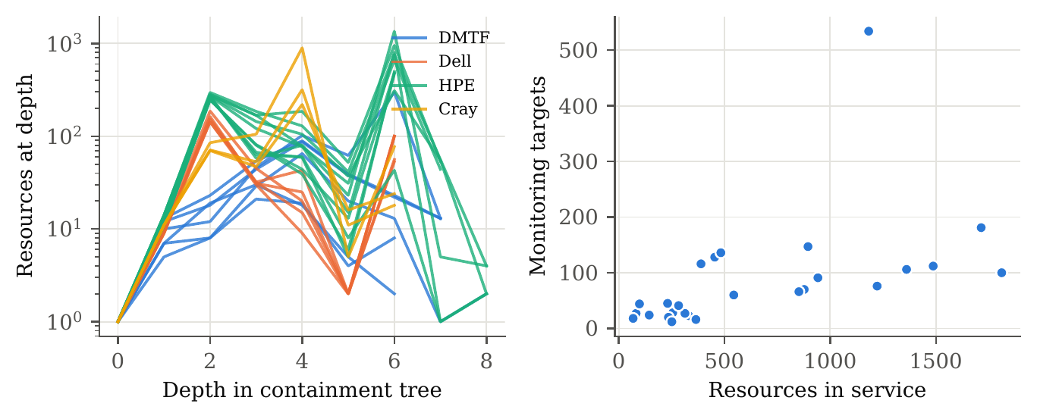
Figure 7.7: Shape of the containment trees: resources per depth for each service, coloured by vendor family (left), and monitored components versus service size (right).
The containment graphs are shallow and broad (Figure 7.7): all 26 services have height $6≤D≤8$, and the number of resources per level peaks at depth 2–5. The share of vertices with more than one containment parent (Eq. (4.3)) is 3.1 % overall. It is highest on the HPE iLO 6/7 services (up to 9.3 %, e.g. drives linked from both chassis and storage) and on the Gigabyte server (12.1 %, resources exposed both under a system and a composition resource block). The almost-tree view is therefore justified, and the seen set of Algorithm 2 deduplicates the remaining multi-parent vertices. Services with more resources tend to have more monitored components, but the relation is loose (right panel), because the bulk of the resources is logs, registries and schemas. The number of monitored components alone therefore predicts discovery cost poorly, which is one more argument for pruning by type rather than by size. Finally, 120 resources on 13 services (mostly HPE and Cray) have no @odata.type; SP-BFS expands them conservatively.

7.7 Discussion

7.7.1 URI patterns versus type-based search
Since protocol version 1.6.0, conforming services must implement the URI patterns published in the schema (Section 3.2). One might therefore replace discovery by expanding the patterns. The patterns do not remove the search, however. Each pattern contains identifier variables that must be bound by reading collections, and the patterns of one type are alternatives (21 for Processor, 8 for Drive), so the client still has to probe which of them the service implements. This amounts to a tree search guided by string templates instead of types. The Dell services in our data, at protocol version 1.0.2, predate the patterns and use URIs such as /redfish/v1/Chassis/System.Embedded.1/Sensors/Fans/0x17||Fan.Embedded.1 that match none of them. URI patterns can still help SP-BFS: where a service declares version $≥1.6.0$, a pattern proves that a type cannot occur below a certain path, which could tighten the type graph further.

7.7.2 Why not follow Links or use $expand?
Following Links would recover the six components that no containment path reaches. But cross references connect almost every hardware resource to its chassis and system, so the traversal would visit most of the graph again (the ground-truth crawl needed 18,205 requests, 5.2 times as many as SP-BFS). A practical compromise is to follow only those cross references whose target type is an anchor type, which the schema also describes. $expand would reduce the number of round trips further, but it is optional and inconsistently implemented, so it can only be an optimisation on top of the traversal, not a replacement.

7.7.3 Threats to validity
Internal validity. The ground truth is defined by the same query predicates as the strategies, so recall measures reachability of the components, not the correctness of the query definitions. We checked the query definitions manually on several services. The categories and the predicate that excludes cores and threads reflect the needs of the author’s monitoring tool; other choices would change the absolute numbers, not the comparison. The static baselines were written by us from the schema. A developer with different habits might write different paths, but Static-union already covers both schema generations and all paths the tools of Section 3.1 use.
External validity. The 26 services come from six vendor families but are dominated by HPE (13 services including Cray). Lenovo, Supermicro, Fujitsu, Inspur and current Dell iDRAC 9 firmware are not represented because no public mockups were available; several of them are known to have their own placement conventions. Mockups are complete recordings, but some may have been edited by their publishers to remove serial numbers or to shorten logs, which affects Tree-BFS cost (and makes it an underestimate) but not the answer sets.
Construct validity. Request count is a proxy for time and BMC load. The latency model uses a single published average, which ignores the difference between cheap and expensive resources (collections with many members, sensor readings requiring bus transactions) and the degradation of BMCs under concurrency. Measurements on live hardware are needed to turn the request and round counts into reliable wall-clock numbers.

8 Conclusion

8.1 Summary
This thesis started from a practical difficulty met while building a Redfish hardware monitoring tool: deciding which REST resource to call for storage, network, power, processors and the other components, when the answer depends on the vendor, the firmware generation and the schema version of each server. Instead of maintaining a growing table of vendor-specific paths, the tool converts the Redfish service into a tree and finds components by breadth-first search on their schema type. The thesis developed this idea into a method with guarantees and evaluated it on real service data.
- We modelled a Redfish service as a typed resource graph whose containment edges form an almost-tree (3.1 % multi-parent vertices, height 6–8), and monitored component classes as declarative queries over types, embedded locations and predicates.
- We showed on 26 services from six vendor families and protocol versions 1.0.2–1.20.0 that placement heterogeneity is real: hard-coded navigation for one schema generation finds only 49–78 % of the 2,248 components, and even a union of both generations misses drives on three HPE servers.
- Type-based tree search finds 99.7 % of the components on every vendor and version with no vendor-specific code; the rest is reachable only through Links or OEM extensions.
- Schema-pruned BFS (SP-BFS) uses a type reachability graph derived automatically from the DMTF schema bundle to skip every branch that cannot contain a requested type. It is provably sound on schema-conformant services and fetches only resources that any schema-only algorithm must fetch. It lost no component on any service, cut requests by a factor of five per service (geometric mean) relative to exhaustive BFS, and came within a factor of 1.22 of a hand-maintained static client.
- Unpruned BFS reaches its first answer later than DFS on Redfish, because the shallow levels are wide and irrelevant; pruning reduces the median time to first answer from 234 to 9 requests. The shallow trees make level-synchronous parallel fetching effective, and separating discovery from polling amortises the remaining cost.
The answer to the research problem is therefore positive: a monitoring client can locate all instances of a hardware class in an arbitrary Redfish service without vendor-specific navigation code, at a request cost close to that of a hand-written client, by letting the published schema guide a breadth-first search. For practitioners the recommendation is simple: describe what you monitor, not where it lives, and let the schema tell the client which links are worth following.

8.2 Limitations
The evaluation relies on recorded services, so wall-clock effects (latency, throttling, degradation under concurrency) are modelled rather than measured. The dataset is dominated by HPE and lacks Lenovo, Supermicro and current Dell firmware. SP-BFS is sound only relative to the containment tree; components that a service exposes solely via Links or OEM subtrees are not found. The type graph over-approximates containment because the JSON Schema does not distinguish contained resources from referenced ones outside Links, which costs requests (e.g. below network device functions) but not completeness.

8.3 Future Work
- Live measurements. Run SP-BFS and the baselines against a fleet of live BMCs to measure latency distributions, the effect of concurrency on BMC response times, and the resulting optimal $c$ per vendor.
- Tighter type graphs. Use the CSDL containment annotation ContainsTarget, and the URI patterns of services at version $≥1.6.0$, to remove reference-only edges from $H$. In the 2026.2 bundle only 214 of 1,030 navigation-property declarations carry ContainsTarget, so this requires either schema improvements or a learned model of which edges are containment in practice.
- Predicate-aware pruning. Propagate content predicates such as “not a core or thread” into the pruning rule, e.g. by learning, per vendor, which subtrees never contain matching instances, with a periodic exhaustive audit to preserve completeness.
- Selective cross references. Follow a Links reference only if its declared target type is an anchor type, to recover the components that are not in the containment tree at little extra cost.
- Deduplication across model generations. Merge the legacy embedded and the new resource representations of the same power supply or fan by Location, SerialNumber and MemberId.
- Server-side assistance. Combine SP-BFS with $expand and $select where a service supports them, and with Redfish event subscriptions and telemetry reports for rediscovery and polling.

Appendix A: Static Navigation Recipes and Queries
The static baselines of Chapter 7 are defined as lists of steps. A property name follows that property (a single link or an array of links), * enumerates the Members of a collection, and #Prop enumerates the elements of an embedded array without a further request. Static-union is the concatenation of both lists per category, evaluated with a shared response cache.
Listing: Static navigation recipes (rfbfs/discover.py).
STATIC_LEGACY = {
"Processor": [["Systems", "*", "Processors", "*"]],
"Memory": [["Systems", "*", "Memory", "*"]],
"Storage": [["Systems", "*", "SimpleStorage", "*", "#Devices"]],
"Network": [["Systems", "*", "EthernetInterfaces", "*"]],
"Power": [["Chassis", "*", "Power", "#PowerSupplies"]],
"Thermal": [["Chassis", "*", "Thermal", "#Fans"],
["Chassis", "*", "Thermal", "#Temperatures"]],
}
STATIC_MODERN = {
"Processor": [["Systems", "*", "Processors", "*"]],
"Memory": [["Systems", "*", "Memory", "*"]],
"Storage": [["Systems", "*", "Storage", "*", "Drives"]],
"Network": [["Systems", "*", "EthernetInterfaces", "*"],
["Chassis", "*", "NetworkAdapters", "*"]],
"Power": [["Chassis", "*", "PowerSubsystem", "PowerSupplies", "*"]],
"Thermal": [["Chassis", "*", "ThermalSubsystem", "Fans", "*"],
["Chassis", "*", "Sensors", "*"]],
}
Listing: Declarative resource queries (rfbfs/queries.py, abridged).
QUERIES = {
"Processor": Query("Processor", {"Processor"}, predicate=_socket),
"Memory": Query("Memory", {"Memory"}),
"Storage": Query("Storage", {"Drive"}, {("SimpleStorage", "Devices")}),
"Network": Query("Network", {"EthernetInterface", "NetworkAdapter"}),
"Power": Query("Power", {"PowerSupply"}, {("Power", "PowerSupplies")}),
"Thermal": Query("Thermal", {"Fan", "Sensor"},
{("Thermal", "Fans"), ("Thermal", "Temperatures")},
_temperature_sensor),
}
EXCLUDED_TYPES = {"ManagerCollection", "Manager"}

Appendix B: Reproducibility

B.1 Data sources
All services and the schema bundle were obtained from public repositories on 19 September 2026 (Table B.1). The mockup directories used are listed in code/run_experiments.py.
Table B.1: Data sources (GitHub repositories) and the commits used.
Content | Repository | Commit | Date
DMTF mockups, schema 2026.2 | DMTF/Redfish-Publications | 4f81814e39 | 2026-09-16
HPE iLO mockups | HewlettPackard/ilo-redfish-emulator | d668ab1580 | 2026-09-09
HPE CSM mockups | Cray-HPE/csm-redfish-interface-emulator | 8d6a108bbd | 2025-12-12
Dell mockups | sailfishdell/sailfish | 3bbe0703c2 | 2019-11-22

B.2 Commands
# fetch data (shallow clones are sufficient)
git clone https://github.com/DMTF/Redfish-Publications.git data/pubs
git clone https://github.com/HewlettPackard/ilo-redfish-emulator.git data/ilo-redfish-emulator
git clone https://github.com/Cray-HPE/csm-redfish-interface-emulator.git \
data/csm-redfish-interface-emulator
git clone https://github.com/sailfishdell/sailfish.git data/sailfish
cd code
python3 run_experiments.py ../data ../data/pubs/json-schema ../results
pip install matplotlib numpy
python3 make_figures.py ../results ../figures # also writes ../tables/*.tex
The experiment is deterministic. On a single core it runs in under one minute. The file results/aggregate.json contains every aggregate number quoted in Chapter 7.

Bibliography
[1] Intel, Hewlett-Packard, NEC, and Dell, IPMI – intelligent platform management interface specification, second generation, v2.0, Document Revision 1.1. 2013. Accessed: Sep. 19, 2026. [Online]. Available: https://www.intel.com/content/dam/www/public/us/en/documents/product-briefs/ipmi-second-gen-interface-spec-v2-rev1-1.pdf
[2] DMTF, “Redfish specification,” Distributed Management Task Force (DMTF), DMTF Standard DSP0266, Version 1.25.0, Aug. 2026. Accessed: Sep. 19, 2026. [Online]. Available: https://www.dmtf.org/sites/default/files/standards/documents/DSP0266_1.25.0.pdf
[3] DMTF, “Redfish data model specification,” Distributed Management Task Force (DMTF), DMTF Standard DSP0268, Version 2026.2, Aug. 2026. Accessed: Sep. 19, 2026. [Online]. Available: https://www.dmtf.org/sites/default/files/standards/documents/DSP0268_2026.2.pdf
[4] J. Li et al., “MonSTer: An out-of-the-box monitoring tool for high performance computing systems,” in 2020 IEEE international conference on cluster computing (CLUSTER), Kobe, Japan: IEEE, 2020, pp. 119–129. doi: 10.1109/CLUSTER49012.2020.00022.
[5] G. Ali, J. Hass, A. Sill, E. Hojati, T. Dang, and Y. Chen, “Redfish-Nagios: A scalable out-of-band data center monitoring framework based on Redfish telemetry model,” in Proceedings of the fifth international workshop on systems and network telemetry and analytics (SNTA ’22), Minneapolis, MN, USA: ACM, 2022, pp. 3–11. doi: 10.1145/3526064.3534108.
[6] V. Dakić, K. Bertina, J. Redžepagić, and D. Regvart, “The RedFish API and vSphere hypervisor API: A unified framework for policy-based server monitoring,” Electronics, vol. 13, no. 23, p. 4624, 2024, doi: 10.3390/electronics13234624.
[7] R. T. Fielding, “Architectural styles and the design of network-based software architectures,” PhD thesis, University of California, Irvine, 2000. Accessed: Sep. 19, 2026. [Online]. Available: https://ics.uci.edu/~fielding/pubs/dissertation/top.htm
[8] OpenBMC Project, “OpenBMC: An open source firmware stack for baseboard management controllers.” Linux Foundation project, GitHub organisation, 2026. Accessed: Sep. 19, 2026. [Online]. Available: https://github.com/openbmc/openbmc
[9] A. J. Bonkoski, R. Bielawski, and J. A. Halderman, “Illuminating the security issues surrounding lights-out server management,” in 7th USENIX workshop on offensive technologies (WOOT ’13), Washington, D.C., USA: USENIX Association, 2013. Accessed: Sep. 19, 2026. [Online]. Available: https://www.usenix.org/conference/woot13/workshop-program/presentation/bonkoski
[10] J. Case, M. Fedor, M. Schoffstall, and J. Davin, “A simple network management protocol (SNMP),” Internet Engineering Task Force, RFC 1157, May 1990. doi: 10.17487/RFC1157.
[11] D. Harrington, R. Presuhn, and B. Wijnen, “An architecture for describing simple network management protocol (SNMP) management frameworks,” Internet Engineering Task Force, RFC 3411, Dec. 2002. doi: 10.17487/RFC3411.
[12] DMTF, “Redfish white paper,” Distributed Management Task Force (DMTF), DMTF Informative Document DSP2044, Version 1.0.0, Aug. 2015. Accessed: Sep. 19, 2026. [Online]. Available: https://www.dmtf.org/sites/default/files/standards/documents/DSP2044_1.0.0.pdf
[13] DMTF, “Redfish resource and schema guide,” Distributed Management Task Force (DMTF), DMTF Informational Document DSP2046, Version 2026.2, Aug. 2026. Accessed: Sep. 19, 2026. [Online]. Available: https://www.dmtf.org/sites/default/files/standards/documents/DSP2046_2026.2.pdf
[14] SNIA, “Swordfish scalable storage management API specification,” Storage Networking Industry Association (SNIA), SNIA Technical Specification Version 1.2.8, 2025. Accessed: Sep. 19, 2026. [Online]. Available: https://www.snia.org/sites/default/files/technical-work/swordfish/release/v1.2.8/pdf/Swordfish_v1.2.8_Specification.pdf
[15] T. Bray, “The JavaScript Object Notation (JSON) data interchange format,” Internet Engineering Task Force, RFC 8259, Dec. 2017. doi: 10.17487/RFC8259.
[16] DMTF, “Redfish host interface specification,” Distributed Management Task Force (DMTF), DMTF Standard DSP0270, Version 1.3.1, Aug. 2023. Accessed: Sep. 19, 2026. [Online]. Available: https://www.dmtf.org/sites/default/files/standards/documents/DSP0270_1.3.1.pdf
[17] DMTF, “Platform level data model (PLDM) for Redfish device enablement,” Distributed Management Task Force (DMTF), DMTF Standard DSP0218, Version 1.2.0, Jun. 2024. Accessed: Sep. 19, 2026. [Online]. Available: https://www.dmtf.org/sites/default/files/standards/documents/DSP0218_1.2.0.pdf
[18] DMTF, “Redfish user guide,” Distributed Management Task Force (DMTF), DMTF Informational Document DSP2060, Version 1.1.0, Aug. 2024. Accessed: Sep. 19, 2026. [Online]. Available: https://www.dmtf.org/sites/default/files/standards/documents/DSP2060_1.1.0.pdf
[19] M. Pizzo, R. Handl, and M. Zurmuehl, “OData version 4.01. Part 1: protocol,” OASIS, OASIS Standard, Apr. 2020. Accessed: Sep. 19, 2026. [Online]. Available: https://docs.oasis-open.org/odata/odata/v4.01/os/part1-protocol/odata-v4.01-os-part1-protocol.html
[20] M. Pizzo, R. Handl, and M. Biamonte, “OData JSON format version 4.01,” OASIS, OASIS Standard, May 2020. Accessed: Sep. 19, 2026. [Online]. Available: https://docs.oasis-open.org/odata/odata-json-format/v4.01/os/odata-json-format-v4.01-os.html
[21] DMTF, “Redfish and OData white paper,” Distributed Management Task Force (DMTF), DMTF Informative Document DSP2052, Version 1.0.0, Apr. 2018. Accessed: Sep. 19, 2026. [Online]. Available: https://www.dmtf.org/sites/default/files/standards/documents/DSP2052_1.0.0.pdf
[22] DMTF, “Redfish schema bundle (DSP8010).” Distributed Management Task Force (DMTF), CSDL, JSON Schema and OpenAPI files, 2026. Accessed: Sep. 19, 2026. [Online]. Available: https://www.dmtf.org/standards/redfish
[23] A. Wright, H. Andrews, B. Hutton, and G. Dennis, “JSON Schema: A media type for describing JSON documents,” Internet Engineering Task Force, Internet-Draft draft-bhutton-json-schema-01, Jun. 2022. Accessed: Sep. 19, 2026. [Online]. Available: https://datatracker.ietf.org/doc/html/draft-bhutton-json-schema-01
[24] OpenAPI Initiative, “OpenAPI specification, version 3.1.1.” Linux Foundation / OpenAPI Initiative, Oct. 2024. Accessed: Sep. 19, 2026. [Online]. Available: https://spec.openapis.org/oas/v3.1.1.html
[25] DMTF, “Redfish Mockup Server.” GitHub repository, 2016. Accessed: Sep. 19, 2026. [Online]. Available: https://github.com/DMTF/Redfish-Mockup-Server
[26] DMTF, “Redfish Mockup Creator.” GitHub repository, 2016. Accessed: Sep. 19, 2026. [Online]. Available: https://github.com/DMTF/Redfish-Mockup-Creator
[27] DMTF, “Redfish interoperability profiles,” Distributed Management Task Force (DMTF), DMTF Standard DSP0272, Version 1.10.0, Apr. 2026. Accessed: Sep. 19, 2026. [Online]. Available: https://www.dmtf.org/sites/default/files/standards/documents/DSP0272_1.10.0.pdf
[28] DMTF, “Redfish Service Validator.” GitHub repository, 2016. Accessed: Sep. 19, 2026. [Online]. Available: https://github.com/DMTF/Redfish-Service-Validator
[29] T. H. Cormen, C. E. Leiserson, R. L. Rivest, and C. Stein, Introduction to algorithms, 3rd ed. Cambridge, MA: MIT Press, 2009.
[30] E. F. Moore, “The shortest path through a maze,” in Proceedings of the international symposium on the theory of switching, part II, in Annals of the computation laboratory of harvard university, vol. 30. Cambridge, MA: Harvard University Press, 1959, pp. 285–292.
[31] M. Najork and J. L. Wiener, “Breadth-first crawling yields high-quality pages,” in Proceedings of the 10th international conference on world wide web (WWW ’01), Hong Kong: ACM, 2001, pp. 114–118. doi: 10.1145/371920.371965.
[32] G. E. Gonçalves et al., “A standard to rule them all: Redfish,” IEEE Communications Standards Magazine, vol. 3, no. 2, pp. 36–43, 2019, doi: 10.1109/MCOMSTD.2019.1800045.
[33] E. Hojati, Y. Chen, and A. Sill, “Benchmarking automated hardware management technologies for modern data centers and cloud environments,” in Proceedings of the 10th international conference on utility and cloud computing (UCC ’17), Austin, TX, USA: ACM, 2017, pp. 195–196. doi: 10.1145/3147213.3149212.
[34] E. Hojati, J. Hass, A. Sill, and Y. Chen, “Redfish Green500 Benchmarker (RGB): Towards automation of the Green500 process for data centers,” in 2020 IEEE green technologies conference (GreenTech), Oklahoma City, OK, USA: IEEE, 2020, pp. 47–52. doi: 10.1109/GreenTech46478.2020.9289729.
[35] NSF Cloud and Autonomic Computing Center, Texas Tech University, “MonSTer: Monitoring tool for HPC metrics from batch scheduler and BMC resources.” GitHub repository, 2020. Accessed: Sep. 19, 2026. [Online]. Available: https://github.com/nsfcac/MonSter
[36] G. Ali, J. Hass, A. Sill, E. Hojati, T. Dang, and Y. Chen, “A scalable, distributed monitoring framework for HPC clusters using Redfish-Nagios integration.” Research Square preprint (CC BY 4.0), Apr. 2023. doi: 10.21203/rs.3.rs-2749012/v1.
[37] A. Agelastos et al., “The lightweight distributed metric service: A scalable infrastructure for continuous monitoring of large scale computing systems and applications,” in SC14: International conference for high performance computing, networking, storage and analysis, New Orleans, LA, USA: IEEE, 2014, pp. 154–165. doi: 10.1109/SC.2014.18.
[38] A. Libri, A. Bartolini, and L. Benini, “DiG: Enabling out-of-band scalable high-resolution monitoring for data-center analytics, automation and control (extended).” 2018. doi: 10.48550/arXiv.1806.02698.
[39] Z. Chen and D. Oswald, “PMFault: Faulting and bricking server CPUs through management interfaces,” IACR Transactions on Cryptographic Hardware and Embedded Systems, vol. 2023, no. 2, pp. 1–23, 2023, doi: 10.46586/tches.v2023.i2.1-23.
[40] D. S. Almeida, P. R. Barros, G. Acioli Júnior, and T. A. M. Euzébio, “Implementation guide for secure RESTful asset management APIs under IEC 62443-4-2: A Redfish case study,” IEEE Access, vol. 14, pp. 42015–42038, 2026, doi: 10.1109/ACCESS.2026.3674966.
[41] DMTF, “Python-redfish-library.” GitHub repository, 2016. Accessed: Sep. 19, 2026. [Online]. Available: https://github.com/DMTF/python-redfish-library
[42] OpenStack, “Sushy: A Python library to communicate with Redfish based systems.” OpenStack project, mirrored on GitHub, 2017. Accessed: Sep. 19, 2026. [Online]. Available: https://opendev.org/openstack/sushy
[43] jenningsloy318, “Redfish_exporter: A Prometheus exporter for Redfish-based hardware.” GitHub repository, 2019. Accessed: Sep. 19, 2026. [Online]. Available: https://github.com/jenningsloy318/redfish_exporter
[44] OpenBMC Project, “Bmcweb: OpenBMC webserver (Redfish, KVM, GUI and D-Bus).” GitHub repository, 2018. Accessed: Sep. 19, 2026. [Online]. Available: https://github.com/openbmc/bmcweb
[45] P. Bryan, K. Zyp, and M. Nottingham, “JavaScript Object Notation (JSON) pointer,” Internet Engineering Task Force, RFC 6901, Apr. 2013. doi: 10.17487/RFC6901.
[46] T. Berners-Lee, R. Fielding, and L. Masinter, “Uniform resource identifier (URI): Generic syntax,” Internet Engineering Task Force, RFC 3986, Jan. 2005. doi: 10.17487/RFC3986.
[47] J. Cho, H. Garcia-Molina, and L. Page, “Efficient crawling through URL ordering,” Computer Networks and ISDN Systems, vol. 30, no. 1–7, pp. 161–172, 1998, doi: 10.1016/S0169-7552(98)00108-1.
[48] J. Cho and H. Garcia-Molina, “The evolution of the web and implications for an incremental crawler,” in Proceedings of the 26th international conference on very large data bases (VLDB 2000), Cairo, Egypt: Morgan Kaufmann, 2000, pp. 200–209.
[49] J. Li, Y. Xiong, X. Liu, and L. Zhang, “How does web service API evolution affect clients?” in 2013 IEEE 20th international conference on web services (ICWS), Santa Clara, CA, USA: IEEE, 2013, pp. 300–307. doi: 10.1109/ICWS.2013.48.
[50] T. Espinha, A. Zaidman, and H.-G. Gross, “Web API growing pains: Stories from client developers and their code,” in 2014 software evolution week – IEEE conference on software maintenance, reengineering, and reverse engineering (CSMR-WCRE), IEEE, 2014, pp. 84–93. doi: 10.1109/CSMR-WCRE.2014.6747228.
[51] T. Espinha, A. Zaidman, and H.-G. Gross, “Web API growing pains: Loosely coupled yet strongly tied,” Journal of Systems and Software, vol. 100, pp. 27–43, 2015, doi: 10.1016/j.jss.2014.10.014.
[52] S. M. Sohan, C. Anslow, and F. Maurer, “A case study of web API evolution,” in 2015 IEEE world congress on services, New York, NY, USA: IEEE, 2015, pp. 245–252. doi: 10.1109/SERVICES.2015.43.

